“Development of a CNN-Based Facial Recognition System for Early Signs of Sleep Deprivation in Students for Health Monitoring"

An Undergraduate Thesis
Submitted to the Faculty of the
College of Engineering, Computer Studies, and Architecture
Lyceum of the Philippines University - Cavite

In Partial Fulfillment
of the Requirements for the Degree
Bachelor of Science in Computer Engineering

ERALDO, CHRISTIAN JUDE E.
TABLATE, KIRK ANDRIE.
DELA CRUZ, CHRISTIAN ANGELO.

December 2025

CHAPTER I
INTRODUCTION
Background of the Study

Sleep is essential for both physical and emotional well-being, both every bodily system depends on both the amount and quality of sleep, and inadequate sleep affects immunity, hormone control, memory consolidation, mental and cardiovascular (CV) health, and immunity. (Baranwal et al., 2023). Furthermore, Sleep, like food, drink, and air, is an essential biological requirement for human survival. Unlike inhaling air, satisfying this biological need requires the individual to participate in volitional acts, similar to food consumption (Grandner, 2022).
One of the most common sleep problems encountered in our country is sleep deprivation it occurs when a person regularly fails to get enough sleep, leading to problems with concentration, behavior, and physical health. According to Kim et al. (2022) Sleep deprivation is known to have negative effects on different cognitive abilities. In particular, it has been noted that sleep deprivation impairs cognitive regulation and memory consolidation. The study highlighted the common effects of sleep deprivation focusing on human long-term memory and cognitive control process such as the working memory or the ability to store information temporarily and it also has adverse effects on human attention. Kazemizadeh and Behpour (2022) highlighted that many studies showed that lack of sleep and the resulting fatigue from it might cause mental and bodily disturbances and health issues that include digestive difficulties, heart problems, risky conduct or behavior, and distractions during work. In contrast, getting enough sleep can lower stress, enhance health, and improve performance.
Nowadays, Convolutional Neural Networks (CNNs) are currently one of the best and most popular neural network applications in deep learning. Taye (2023) discussed the fundamentals and concepts of convolutional neural network. Based on the discussion, Convolutional Neural Networks (CNNs) are one of the primary types of neural networks that are used for image recognition and classification. CNNs have a number of uses, some of them include object recognition, image processing, computer vision, and face recognition. Input for the convolutional neural networks is given in the form of images. Convolutional neural networks are used to automatically learn a hierarchy of features which can be used for classification (rather than manually creating features). In achieving this hierarchy of feature map is constructed by iterating convolutions of the input image with learned filters. Due to the hierarchical method, more complex features, which are also distortion and translation invariant, can be learned by higher layers.
Health monitoring is important in ensuring early diagnosis and prevention of diseases and in this case students are at risk of experiencing stress and sleep deprivation. In the era of technological progress, health monitoring systems have adopted the use of sensors and intelligent algorithms to monitor vital signs and behavior patterns in real time, and through interventions that enhance well-being and academic performance (Al-Adwani & Al-Siyabi, 2023). Based on the study of Pratama et al. (2024) The use of technology, such as artificial intelligence, could be one of the most important success elements in the implementation of health-promoting universities, increasing the effectiveness and efficiency of all stages of health promotion and prevention operations. AI-enabled integrated health monitoring in university settings was projected to greatly enhance student health promotion, disease prevention, and personalized health management.
Sleep deprivation in college students is prevalent due to heavy workloads, multiple requirements, quizzes, and exams from different core subjects. Based on a study conducted by Suardiaz‑Muro et al. (2023) The percentage of university students who sleep poorly is greater than that of students who sleep well during examination periods. Additionally, the researchers emphasized that the majority of evidence indicates that improved sleep quality is linked to improved academic performance. Furthermore, daytime sleepiness is the most evident effect of insufficient sleep in terms of length, quality, and regularity. This particular study has showed the negative effects of sleep deprivation on the academic performance of university students, further emphasizing the importance of a health monitoring system on universities.
In a remarkable research Conducted by Prasad and Chandana (2023) trained a MobileNetV3, a lightweight CNN architecture, to detect the facial emotions of a person based on thermal infrared pictures. This system consists of five steps, namely noise elimination with a mean filter, normalization of the data with the min-max algorithm, key facial area feature extraction with the Binary Dragonfly Algorithm (BDA), facial area division with the Enhanced Crow Search Algorithm (ECSA), and face recognition with a dense-UNet model. The last classification of emotions, that is, neutral, sad, fearful, happy, contempt, surprise, laughing, and anger, is carried using MobileNetV3. The model has performed exceptionally high on the IR and IRIS Thermal/Visible datasets with a 99.78% accuracy, 99.54% precision, 99.29% recall and a F1-score of 99.08 performing better than existing emotion-recognition algorithms. This demonstrates how CNN and lightweight architectures like MobileNetV3 can be used in the proposed study to identify early signs of sleep deprivation in educational settings through facial images from students.
With this in mind, the researchers propose of creating a system that can detect if a particular student is sleep deprived and give recommendation on how to deal with it using the input from professionals such as a sleep expert or an Ear, Nose, Throat (ENT) doctor. The device uses a CNN-based facial recognition model to assess facial cues acquired by a camera, such as eye redness, drooping eyelids, and lethargic emotions. When a student is identified as potentially sleep deprived, the system offers individualized health recommendations based on expert insights, which may include lifestyle adjustments, sleep practices, or medical consultation, as needed. Furthermore, the system includes a web-based platform that allows school health admin to monitor results in real time while students receive feedback on mobile devices for prompt assistance. This research aligns with Sustainable Development Goal 3 (SDG 3), which promotes excellent health and well-being by encouraging healthy habits and facilitating early diagnosis of health concerns.

Objectives of the Study
The primary objective of this study is to create and develop a "CNN-Based Facial Recognition System for Early Signs of Sleep Deprivation in Students." This system aims to provide functionalities such as accurate facial recognition, as well as monitoring indicators of sleep deprivation based on facial changes.
The study specifically aims to:
- Design a user-friendly facial recognition system using Convolutional Neural Networks (CNN) capable of detecting signs of sleep deprivation.
- Design and implement a deep learning model to assess whether the individual is sleep-deprived based on the presence of major facial features indicative of sleep deprivation, such as droopy eyelids, dark circles under the eyes, eye redness, reduced facial muscle tone, evident signs of fatigue, and pale skin.
- Design and develop a web application for student health monitoring and early intervention by displaying detection results, historical records, and automated alerts to the parents.
- Test and validate the acceptability of the proposed study's output system using the following criteria: (a) Functional Suitability, (b) Performance Efficiency, (c) Reliability, (d) Usability, and (e) Accuracy.
- Evaluate the acceptability of the output system of the proposed study based on the following ISO/IEC 25010 criteria: (a) Functional Suitability, (b) Performance Efficiency, (c) Reliability, (d) Usability, and (e) Accuracy.

Conceptual Framework
Figure 1
IPO diagram for this Research Study (Conceptual Framework)
Output
Process
Input

- Software Development:

Facial Recognition:
- Use Python, Jupyter Notebook, and Machine Learning Frameworks to develop the CNN model.
- Implement CNN architecture to classify faces and detect anomalies related to sleep deprivation

Sleep Deprivation Detection:
- Use the trained CNN model via Flask and PHP to identify signs of sleep deprivation from the captured image

Web Creation:
Develop a web-based interface using Flask/PHP and Firebase

- Hardware Development:
- Configure camera to capture the face of students if all requirements are met.
- Configure sensors to check human presence and distance.

- Testing

- Validation

- Evaluation

Knowledge Requirement:
- Python Programming and Deep Learning Basics
- Convolutional Neural Networks (CNNs)
- Data Processing Techniques (Image Augmentation)
- Machine Learning Frameworks
- Database Management
- Web Programming

Hardware Requirements:
- High-Resolution Camera
- Raspberry Pi
- LED Indicators (for feedback)
- Power Supply
- LCD Touchscreen
- Ultrasonic Sensor
- Temperature Sensor
- GSM Module

Software Requirements:
- Raspbian OS
- Python
- Jupyter Notebook
- Firebase
- Flask
- PHP
- JavaScript

Development of a CNN-Based Facial Recognition System for Early Signs of Sleep Deprivation in Students for Health Monitoring

The diagram outlines the development of a CNN-based facial recognition system aimed at detecting early signs of sleep deprivation among students. Input requirements include knowledge of Python, deep learning, CNNs, data preprocessing, machine learning frameworks, and SQL, along with hardware components like a high-resolution camera and Raspberry Pi. The process involves software development that includes training a facial recognition model to capture student images, implementing early sleep deprivation detection through facial changes. The output consists of a web-based monitoring dashboard for displaying sleep recognition alerts, alongside data-driven insights to assist individuals in making informed decisions regarding health.

Significance of the Study
The development of the CNN-Based Facial Recognition System for Early Signs of Sleep Deprivation in Students for Health Monitoring provides meaningful contributions to student wellness, institutional support, and academic research. This study highlights how deep learning technologies can be integrated into school environments to promote early health intervention and improve educational outcomes.
- Student Health:
The system directly benefits students by providing an automated method for detecting early signs of sleep deprivation based on facial cues. Lack of sleep is strongly associated with reduced concentration, impaired cognitive processing, increased stress, and overall decline in academic performance. By offering real-time feedback and personalized recommendations, the system promotes health awareness and encourages students to adopt healthier sleep habits. This early-detection approach aims to prevent long-term sleep problems and support students’ physical and mental well-being.

- Educational Institutions:
The system supports educational institutions by providing valuable insights into the sleep patterns and well-being of students. Faculty and school health personnel can use the summarized data to identify students who may be at risk of fatigue-related academic decline, allowing appropriate intervention when needed. With centralized monitoring through a secure web interface, schools can strengthen its wellness initiatives and promote a healthier learning environment. This contributes to improved student engagement, better overall academic performance, and a more responsive support system within the institution.
- Research and Education:
The proposed prototype contributes to ongoing research in computer vision, deep learning, and school-based health innovation. By demonstrating the feasibility of deploying lightweight CNN models such as MobileNetV3 on resource-constrained hardware like the Raspberry Pi, the study provides practical insights for future developers and researchers. It serves as a reference for exploring automated health-monitoring systems, expanding the use of AI-driven tools in educational settings, and encouraging collaboration across technology, psychology, and health sciences. This enhances scientific understanding of how machine learning can be applied to detect physiological and behavioral patterns, including those related to student wellness.
- Parents:
Parents also benefit from the system through timely notifications regarding their child’s sleep condition. Early awareness allows families to take proactive steps in addressing unhealthy sleep routines and monitoring behaviors that may affect academic performance or emotional health. By keeping parents informed, the system ensures that student support extends beyond the classroom. This empowers parents to participate more actively in maintaining the well-being of their children.

Scope and Limitations
The scope of this study includes the development and implementation of a CNN-based facial recognition system that will identify signs of sleep deprivation in students on the basis of facial indications (e.g., droopy eyelids, dark circles, puffy red eyes, and pale skin). Its components are automated face capture with the help of the OpenCV, sleep-deprivation detection with the help of the MobileNetV3-based CNN model, an online interface that shows the results and simple security measures that prevent unauthorized access. The main processing module will be a Raspberry Pi 5 that will execute CNN models, data flow, local storage, and communication with the camera and the web server. A web camera is used to capture facial images to be used in recognizing the faces and also measures sleep-deprivation and a Flask framework is used to provide a web interface that will be easily accessible to the students and other authorized personnel. Firebase stores all the student information, images caught and outputs of the detectors and offers secure and cloud-based storage that is accessible through the interface of the system. The prototype will be used in indoor settings, including classrooms or the entrance to the school premises. It is also based on only and does not include physiological measures. The selected college students of the Lyceum of the Philippines University (LPU) will be used to test the usability and acceptability of the system through the ISO/IEC 25010 quality criteria and measure model performance with the help of an expert labeled dataset. The system will provide alerts that will assist the students and parents to monitor and manage the general wellness of the student.
The limitations of the study include potential challenges with facial recognition accuracy under varying lighting conditions, occlusions (e.g., students wearing masks or glasses), and changes in students’ appearances over time (such as hairstyles or facial accessories). The detection model solely relies on the visible signs of sleep deprivation (e.g., droopy eyelids, dark circles, puffy red eyes, and pale skin), Additionally the system does not include physiological information such as heart rate or brain activity. In terms of distance of the student from the camera, the system will have an optimal function within the range of approximately 0.5 to 1 meter similar to a study conducted by Doctor et al. (2024) for facial recognition. Nevertheless, the system aims to provide an effective and non-invasive tool of determining if a student is sleep deprived to give early interventions. Furthermore, the system is designed for indoor use in classrooms and may not perform well in different or outdoor environments. Privacy concerns and the need for consent for facial data collection also limit the system’s deployment and use.

Definition of Terms
Convolutional Neural Network (CNN). The CNN will be utilized as the primary algorithm for processing and analyzing facial images, enabling the system to accurately recognize and differentiate between students' faces and to detect signs of sleep deprivation on students.
Database Management. Refers to the process of handling and storing of student facial image, student data, and detection results. Either on Raspberry Pi or remotely via the web application, the database allows for the safe storing, retrieval, and updating of records.
Deep Learning. subset of machine learning utilized to improve the CNN's capacity to identify sleep deprivation without the need for manual training by allowing it to automatically recognize and extract patterns from facial photos.
Facial Recognition System. The part of the system that recognizes and examines students' faces in real time. Connects facial information to each student's associated database record and automates the identification procedure to confirm identity.
Firebase. A cloud-based platform by Google will be utilized to securely store user information, detection results, and student facial photos. This is also where the web-based application will obtain the data for the website viewing.
Internet of Things (IoT). represents how system components like the web platform, camera, and Raspberry Pi are connected in a common network, allowing for the constant gathering, sending, and monitoring of health and facial recognition data for the study.
Machine Learning. The study will use a branch of artificial intelligence to train the CNN model on huge facial image datasets. The method increases its prediction accuracy in identifying and categorizing facial traits associated with sleep deprivation
MobileNetV3. This study uses a lightweight and effective CNN architecture to diagnose sleep deprivation and recognize faces in real time. MobileNetV3 offers great accuracy with little power and processing needs, making it ideal for Raspberry Pi.
Python. The programming language that will be used for the development of CNN algorithm and the integration of software into the system, as well as communication between the Raspberry Pi, web application, and Firebase database.
Raspberry Pi. The processing unit will serve as the computational backbone of the system, executing the CNN algorithms and managing data processing tasks to facilitate real-time analysis and decision-making based on camera input.
Sleep Deprivation Detection. To identify whether a student is exhibiting symptoms of sleep deprivation, the system analyzes facial indicators including drooping eyelids, yawning, and changes in skin tone. This enables timely health awareness and action.
Web-Based Application. Through the use of IoT, students can utilize this application to monitor early signs of sleep deprivation and identify the recommended steps to take.

CHAPTER II
REVIEW OF RELATED LITERATURE
This chapter discusses the related literature and studies that the researchers have gathered to help better understand the topic under study. The summary of all the gathered findings, research, and related literature is in the synthesis provided at the end of this chapter.

CNN (Convolutional Neural Network)
According to Ma'arif et al. (2022) Deep learning technologies increasingly mimic human abilities, including information acquisition, problem-solving, and decision-making. Deep learning can train itself without human intervention. Convolutional neural networks (CNNs) are deep learning algorithms widely employed in various applications. CNN is commonly used for image classification, segmentation, and object detection. As well as for speech recognition, natural language processing, and video processing. CNN is comprised of four layers namely, convolution, pooling, fully connected, and non-linear layer. These layers are important for the model to learn the complex patterns from the images or datasets to be given. Similarly, Bhatt et al. (2023) demonstrated that advanced CNN architectures, specifically ensembles of ResNet and DenseNet, achieved diagnostic accuracy surpassing board-certified radiologists in detecting early-stage melanoma from dermoscopic images. Their work highlighted that transfer learning remains a vital technique for overcoming data scarcity in rare disease categories.
A local study conducted by Velasco et al. (2022) presented how the Convolutional Neural Network (CNN) can be used in the medical field. The objective of the said study is to determine visual patterns between tumor and healthy MRI scans. Using Kaggle.com the researchers were able to gather 493 total pictures, 225 labeled as tumor and 268 labeled as normal. The dataset is then further divided for validation and testing. Results showed that after the transfer learning with pre-trained CNN models namely; VGG-16 and VGG-19 and applying data-augmentation methods the model was able to get approximately 95% validation accuracy. The authors still recommend further research and a larger dataset if the system is to be used predicting and interpreting patterns on the MRI scans.

Sleep Deprivation
Sleep deprivation causes a variety of performance declines that could be dangerous for one's job. Numerous research has examined the consequences of sleep deprivation. on subjective, behavioral, physiological, and cognitive tests. For instance, new research shows that a night of lack of sleep impairs the capacity of an individual to react to duties appropriately, leading to poorer reaction times, more errors in attention, as well as reductions in memory. Additionally, recent studies have demonstrated that sleep deprivation causes elevated subjective drowsiness and a rise in behavioral outcomes that cause individuals to take more risks, have fewer inhibitory controls, and be less able to identify and fix mistakes, as well as a higher chance of making errors (Kayser et al., 2022).
According to Rogayan and Padre (2025), the country is experiencing a "sleep epidemic," which is quietly contributing to increased cardiovascular risk among Filipinos. Their findings demonstrated that insufficient sleep alters hormonal control, raises stress levels, and increases the risk of hypertension, obesity, and metabolic problems. Furthermore, the authors noted that chronic sleep deprivation is a systemic health problem that requires early behavioral intervention. Moreover, as cited by the Philippine Society of Sleep Medicine Inc. (PSSMI), the Philippines ranks first in Southeast Asia and is number four globally among the most sleep-deprived nations. This further shows the importance of the proposed study for early detections and interventions of sleep deprivation.

Raspberry Pi and its Application
Based on the study of Hosny et al. (2023) the Raspberry Pi is a low-cost and energy-efficient computing device, it is used in IoT applications to do similar duties as traditional desktop computers. Raspberry Pi is a four-core computer, the parallel processing enables faster computations and processes. This microprocessor is a versatile and cost-effective technology perfect for IoT applications due to its portability, parallelism, and low power consumption. Furthermore, a study conducted by Ju et al. (2023) showed the capability of Raspberry Pi in running lightweight CNN models, emphasizing that using a neural network on Raspberry Pi is more efficient than cloud-based broadcasts. The assumption is that the neural network has a modest amount of computation. In this study, the proponents will utilize Raspberry Pi 5 to enable faster processing of the images and for smooth communication between the hardware and the website.

Signs of Sleep Deprivation Using Facial Cues
The researchers plan to use the CNN’s ability to recognize facial cues or patterns to detect signs of sleep deprivation onto the students. The study of Léger et al. (2022) highlighted that in addition to increasing dark circles beneath the eyes, modest sleep restriction (three hours per night for two nights) had a substantial impact on face skin parameters such hydration, trans-epidermal water loss, elasticity, brightness, and saturation. Due to sleep debt, these physiological skin changes lead to noticeable changes in facial appearance, which may have an impact on social behavior. Such patterns are being considered by the researchers as parameters that the system needs to detect in order to classify students with sleep deprivation.
Furthermore, indicators of sleep deprivation are not only reflected in facial features but can also be observed through changes in skin tone. Matsubara et al. (2023) examined how sleep deprivation affected the look of facial skin with a focus on skin color alteration. In the study’s clinical trials, they found that while hydration temporarily dropped and redness stayed unchanged, both complete sleep loss and recurrent partial sleep restriction dramatically increased the yellowness of facial skin. These changes were not followed by increases in systemic stress and inflammatory markers, carotenoids, or blood bilirubin, indicating that the observed yellowness most likely results from local skin processes rather than systemic mechanisms. The results emphasize the relevance of skin tone as a significant indicator for sleep deprivation by highlighting skin yellowness as a possible external signal of inadequate sleep.

Edge Computing
As stated by Kong et al. (2022) The fundamental idea behind edge computing is to place data processing in near-edge devices, in this case the Raspberry Pi, rather than remote cloud servers. It promises to construct more scalable, low-latency IoT systems. Moreover, the integration of the Internet of Things (IoT) and edge computing is targeted at achieving seamless computing anytime and anywhere through the integration of two distinct roles. IoT is focused on data sensing at endpoints, while edge computing is focused on near-field data processing. Together they form Edge-Computing-Driven IoT (ECDriven-IoT) systems which improve different modern applications like smart homes, cities, grids, VR/AR, autonomous vehicles and more. The integration of the two has three main advantages, better real-time response and quality of service, low power consumption, and offers greater scalability.

CNN Architectures for Edge Computing
MobileNet Compression and Edge Computing Strategy for Low-Latency Monitoring
Lightweight CNN architectures fit perfectly for edge computing devices since the devices involved are resource constrained and cannot efficiently process CNN models that require high memory demands. The MobileNet architecture is currently one of the most popular solutions for edge computing applications due to its lightweight and computational efficiency. The paper "MobileNet Compression and Edge Computing Strategy for Low-Latency Monitoring" by Zhan (2024) shows that the combination of MobileNet with edge computing can really improve real-time performance in wearables in IoT. Through depth wise separable convolutions and a dynamic channel pruning mechanism, MobileNet gives significant model reduction and inference latency while achieving high recognition accuracy. Its optimizations make it suitable for deployment in resource constrained edge devices, providing faster data processing and lower energy consumption while maintaining reliability. In addition, the research has proposed an entropy-based edge collaboration scheme in which intelligent task assignment between local devices and edge servers is conducted to optimize the workload balance and achieve lower power consumption.

A Real-Time and Privacy-Preserving Facial Expression Recognition System Using an AI-Powered Microcontroller.
The study titled "A Real-Time and Privacy-Preserving Facial Expression Recognition System Using an AI-Powered Microcontroller" (Zhang et al., 2024) contributes to a growing body of research focused on enhancing facial expression recognition (FER) through the integration of artificial intelligence and edge computing. Previous studies have emphasized the use of AI-powered microcontrollers to enable real-time FER by executing lightweight neural network models directly on embedded systems. This approach significantly reduces latency and allows for on-device processing, which also enhances user privacy. Research in privacy-preserving techniques has also gained traction, with many proposing methods such as data encryption, anonymization, or edge-based inference to prevent sensitive facial data from being exposed or transmitted. In terms of performance, various studies have explored optimized convolutional neural network (CNN) architectures and hardware accelerators to ensure that real-time recognition does not compromise accuracy. Additionally, FER systems have been widely studied for their applications in human-computer interaction, particularly in adaptive systems that respond to users’ emotional states in real time. Collectively, these related works provide a strong foundation for the development of efficient, secure, and user-friendly facial expression recognition technologies like the one proposed by Zhang et al. (2024).
Deep Learning System Application on Educational System
Automatic attendance system based on CNN–LSTM and face recognition
The Covid-19 pandemic has catalyzed a massive transformation in the education sector, forcing institutions to rapidly shift from conventional face-to-face instruction to digital learning environments. This abrupt transition posed several challenges, one of which is the efficient and accurate monitoring of student attendance. Traditional methods, both in offline and online settings, often require manual intervention and are prone to errors, making the process time-consuming and unreliable. As a response, researchers have explored a variety of automated attendance tracking systems based on emerging technologies such as biometrics, barcodes, QR codes, and mobile devices (Shukla et al., 2023). While these systems have streamlined attendance procedures to some extent, early algorithmic implementations were hampered by low accuracy and high processing times.To address these limitations, more advanced machine learning techniques have been introduced. In particular, the integration of convolutional neural networks (CNNs) with long short-term memory (LSTM) models has shown promise in enhancing both the accuracy and efficiency of face recognition-based attendance systems. CNNs excel at extracting spatial features from images, while LSTMs are effective in capturing temporal dependencies, making the combined CNN–LSTM architecture a robust solution for dynamic attendance scenarios (Shukla et al., 2023).

A CNN-based Automatic Attendance System Design
Face recognition is one of the well-known applications of convolutional neural networks (CNNs). In this paper, we have developed a system that automatically marks students’ attendance in a class. The system uses the Viola-Jones algorithm for face detection from an image and a CNN model for face recognition. A graphical user interface (GUI) was designed in MATLAB® to simplify the overall attendance process in the classroom. The system generates a Microsoft Office Excel sheet showing the students present in the class. The accuracy of the proposed model for our dataset is 90% in a typical class of 20 students (Notkani et al., 2023).
The following studies under this section presented the effectiveness and efficiency of different CNN architectures in recognizing faces of students and how the different models are applied in an institutional setting. Additionally, the models work well for tasks such as attendance tracking and behavioral analysis.

Performance Analysis of Different CNN Models
As shown in Table 1, Ratul et al. (2025) presented a comparative analysis of multiple convolutional neural network (CNN) architectures with varying degrees of complexity in order to compare modern acceleration frameworks. Because of their effectiveness and lightweight construction, a few of the models covered are particularly useful to edge computing on devices like the Raspberry Pi.

Table 1
Details of selected models based from the Study of Ratul et al. (2025)
Model | Params (M) | Representativeness
Resnet-152 | 60.2 | Deep, high-capacity CNN used as a benchmark for classification tasks.
MobileNetV2 | 3.4 | Lightweight architecture optimized for mobile and edge devices.
SqueezeNet | 1.2 | Extremely compact model suitable for highly resource-constrained environments
EfficientNet-B0 | 5.3 | Balances accuracy and efficiency; commonly used in edge scenarios.
VGG16 | 138 | High-capacity model with historical significance; included for comparative completeness.
Swin Transformer | 29 | Vision transformer model; representative of recent architectural trends.
YOLOv5s | 7.2 | Real-time object detector widely adopted in embedded and edge AI applications.

Based from the table provided, the notable models suitable for this research are MobileNetV2, SqueezeNet, EfficientNet-B0, and YOLOv5s. MobileNetV2 is emphasized as a lightweight architecture designed especially for edge and mobile devices. It greatly lowers the number of parameters (3.4M) without sacrificing accuracy by using depthwise separable convolutions. Because it strikes a balance between prediction effectiveness and computing efficiency, this model is frequently used in embedded AI applications. With just 1.2 million parameters, SqueezeNet is one of the smallest CNN models. Its architecture was created to reduce the model's size while preserving a respectable level of accuracy, which makes it ideal for environments with limited resources, such as Raspberry Pi. However, its drastic parameter reduction may result in lower accuracy than other lightweight models, which would restrict its use in tasks that needs greater precision. EfficientNet-B0, with 5.3M parameters provides a good mix between efficiency and accuracy. By optimizing depth, width, and resolution through compound scaling, it outperforms SqueezeNet while still being practical for edge deployment. Finally, with allows for real-time detection performance on platforms such as Raspberry Pi. Its integration into edge-based systems shows that advanced detection capabilities can be implemented without the need for expensive GPUs.

Exploring Lightweight CNN Models
Ding et al. (2023) presented a study titled “A Non-Destructive Method for Identification of Tea Plant Cultivars Based on Deep Learning” this study highlights a comparison between lightweight CNN models. The study used various lightweight deep learning models to categorize tea plant varieties. They used scaled photos with varying sizes to test EfficientNet-B0, MobileNetV2, MobileNetV3, MobileViT-S, and ShuffleNetV2. All models obtained very high accuracy, exceeding 98%, according to the data. With an accuracy of 99.67%, MobileNetV2 outperformed the others, followed by ShuffleNetV2 and MobileNetV3, both of which achieved above 99%. Although they did not perform as well, EfficientNet-B0 and MobileViT-S were nonetheless very accurate. According to the study, lightweight CNN models in particular, MobileNetV2 are dependable options for image classification tasks while yet being sufficiently effective to run on smartphones with constrained processing resources, as seen in Table 2
Table 2
Accuracy of Different Lightweight CNN Models from the Study of Ding et al. (2023)
CNN Model | Accuracy (%)
MobileNetV2 | 99.67
MobileNetV3 | 99.33
ShuffleNetV2 | 99.00
MobileViT-S | 98.67
EfficientNet-B0 | 98.33

Another study conducted by Shahriar (2025) shows several CNN models tested using the CIFAR-10 dataset, with an emphasis on how well-suited they are for low-resource systems. MobileNetV3, ResNet18, EfficientNetV2, SqueezeNet, and ShuffleNetV2 were the models that were compared. Although it came at the expense of a bigger model size (76.97 MB) and a longer inference time, the results showed that EfficientNetV2 had the greatest accuracy (96.53%) and F1 Score (0.9607). A balance was offered by MobileNetV3 and ShuffleNetV2, both of which achieved almost 95% accuracy with quick inference speeds and relatively small model sizes (5.89 MB and 4.82 MB, respectively) as shown in Table 3.

Table 3
Performance of Lightweight Models on CIFAR-10 from the Study of Shahriar (2025)
Model | Accuracy (%) | F1 Score | Inference Time  (sec / image) | Model Size (MB)
MobileNetV3 | 95.49 | 0.9533 | 0.000081 | 5.89
ResNet18 | 96.05 | 0.9578 | 0.000039 | 42.65
EfficientNetV2 | 96.53 | 0.9607 | 0.000123 | 76.97
SqueezeNet | 84.48 | 0.8359 | 0.000037 | 2.78
ShuffleNetV2 | 95.83 | 0.9512 | 0.000100 | 4.82

Based on the reviewed studies the MobileNetV3, emerges as the most appropriate CNN architecture for the study. MobileNetV3 perfectly balances accuracy, computational efficiency, and edge device adaptability. The model continuously achieves competitive accuracy with far lower latency and power consumption than heavier models like VGGNet, ResNet, or DenseNet, which provide excellent accuracy, however the said architectures have high memory and processing requirements that are not suitable for edge computing.

MobileNetV3
The MobileNetV3 CNN architecture is specifically designed for mobile devices and known for its lightweight design. As discussed in recent study by Guo et al. (2024) MobileNetV3 is a lightweight deep learning model. It is commonly used in mobile devices and edge computing due to its small size and excellent processing efficiency. It uses the NetAdapt algorithm to calculate the appropriate number of convolutional kernels and channels, increasing model efficiency. According to Yang et al. (2024) the NetAdapt algorithm automatically adapts a pre-trained network to a mobile platform within a resource budget. This algorithm is directed by indicators of resource utilization. NetAdapt uses empirical measures to analyze direct metrics, eliminating the need for platform-specific expertise. It produces and measures multiple network proposals on the target platform during each iteration and uses the observations to develop new network ideas for the following iteration. These studies demonstrate the MobileNetV3 architecture's applicability for edge computing applications, especially when installed on the Raspberry Pi 5 microcomputer. The next part will discuss about the MobileNetV3’s implementation on image classification.

MobileNet-Based Facial Classification Systems
MobileNetV3: A Deep Learning Technique for Human Face Expressions Identification
The study of Prasad and Chandana (2023) proposes a unique deep-learning technique using MobileNetv3 to classify facial emotions in thermal photographs. It uses five processes to recognize and classify emotions on human faces. The main goal of the research is to use the MobileNetV3 to classify the face into expressions such as neutral, sad, fearful, happy, contempt, surprise, laughing, and anger. The researchers initially performed image preprocessing (noise removal by mean filter, normalization), followed by feature extraction (using Binary Dragonfly Algorithm, BDA), face segmentation (with Enhanced Crow Search Algorithm, ECSA), and face detection via Dense-UNet. The study used two thermal face expression databases, IR database and IRIS Thermal/Visible database. A total of 1,728 sample images that includes eight expression categories are used from the IR database. For the IRIS Thermal/Visible database, the researchers used facial expression data from 30 individuals. Each expression category had approximately 11 image samples per participant, taken under a variety of situations such as varying head orientations and low-light environments. The result shows that MobileNetV3 and the suggested preprocessing and segmentation techniques produced extremely high facial expression recognition accuracy of 98.21% on the IR database and 99.08% on the IRIS Thermal/Visible database, proving its dependability and effectiveness for real-time emotion detection even in the face of difficult circumstances like low light and different head positions.

Masked Face Recognition Using MobileNet V2 with Transfer Learning
The study presented by Shukla and Tiwari (2023) intended to address the COVID-19 pandemic's face recognition problem using masks. Traditional recognition techniques do not work well with masks since they obscure important facial characteristics like the lips and nose. For this purpose, the researchers suggested to use MobileNetV2 combined with transfer learning. The MobileNetV2 technology uses deep features like feature extraction and deep learning model for identifying faces even with mask. This study showed that MobileNetV2 with transfer learning can effectively distinguish both masked and unmasked faces, with a recognition accuracy of 99.82% on a suggested dataset of 8,169 photos collected from Kaggle and other sources from the internet. MobileNetV2 regularly outperformed VGG16, VGG19, ResNet50, and ResNet101 in terms of accuracy and efficiency, demonstrating that it is an ideal CNN model for real-world, resource-limited applications like edge devices.
How to Prevent Drivers Before Their Sleepiness Using Deep Learning-Based Approach
The study done by Akrout and Fakhfakh (2023) aimed to prevent traffic accidents by utilizing a non-invasive technology that is based on deep learning to predict the presence of hypo vigilance in a driver to stop any accident before it happens. The researchers used MediaPipe Face Mesh to identify landmarks and normalize iris, which was then feed into a transfer learning model consisting of the MobileNetV3-large and Deep LSTM network to handle the time-based aspect. This model has been trained and evaluated on the MiraclHB, YawDD and DEAP databases, in particular the vigilance was classified into five categories: awake, a little tired, tired, very tired, and hypovigilance. Findings showed a strong performance with a total accuracy of 98.4 which shows that the system is able to perform better than the traditional face detection algorithms such as Viola-Jones especially when it comes to rotating the heads and partially covering the face. The main benefit of the system is that it can analyze the time, thus having the ability to warn the drivers in the early signs of fatigue, and not only to recognize the sleep events. However, the study also found some limitations on the changes in lighting condition including night driving and proposed future researchers should include, yawning and distraction detection be in order to make the study robust.

MobileNet-Based Detection for Medical Application
A New Method for Detecting the Fatigue Using Automated Deep Learning Techniques for Medical Imaging Applications
Gnanadesigan et al. (2024) introduced automated deep learning method for medical imaging applications that identify fatigue. The goal of the study was to use visual characteristics from image data to categorize people into three groups: alert, non-vigilant, and fatigued. To assess performance, the authors used pretrained convolutional neural network models, such as MobileNetV2, ResNet50, and AlexNet. The said models will enlarge, filter, train, compress, and test through the subjects' neurons. Following the structural embedding of the model, the layers and non-linear capabilities are intended to provide effective metrics. With a 99.8% accuracy rate, the proposal provides the highest accuracy for the well-known MobilenetV2 model and verifies it with excellent performance outcomes.

Skin Disease Prediction using the MobileNet Approach
Dalhmeier and Xiao (2023) presented a study about a system that uses a CNN model based on MobileNet to enable users to detect specific skin diseases through an Android mobile app. Using a sizable image dataset that contains both sick and non-skin-related photos, the model is trained to identify six skin conditions: psoriasis, eczema, seborrhea, tinea/ringworm, acne, and actinic keratosis. The researchers collected about 1,000 photos for each disease class in the dataset, for a total of thousands of photographs for training. Without the need for specialist medical equipment, the final system is meant to be quick, easy, and affordable. Based from the result of the study, the MobileNet model classified the six types of skin diseases with an accuracy of about 81%. The model's success demonstrates its potential to lower consultation costs and improve consumers' access to skin health diagnostics at home by detecting skin diseases early on using common devices.

Synthesis
The literature and studies reviewed highlight the immense progress in computer vision and deep learning, specifically the use of Convolutional Neural Networks (CNNs), Raspberry Pi, and edge computing to automate the process of facial recognition and health monitoring. All of these technologies and research provide a platform to create an effective and inexpensive systems that would identify early signs of sleep deprivation with the help of facial analysis.
Convolutional Neural Networks (CNNs) has been found to be very useful in tasks of extracting features and classifying images. CNNs can be used to train systems based on complex patterns through specific datasets, which constitute specific behaviors, such as object detection, facial recognition, and medical image interpretation, as pointed out by Ma'arif et al. (2022). This efficacy is also justified with the results of the study of Velasco et al. (2022), which reported the 95 percent validation accuracy with the tumor detection with the help of CNN models. Such studies make CNNs a credible foundation in executing diagnostic and recognition systems based on images.
Another important finding in this review is the correlation between the lack of sleep and certain facial alterations. Research by Leger et al. (2022) and Matsubara et al. (2023) proves that poor sleep leads to visible changes to the faces, such as drooping eyelids, eyelid dark circles, and discoloration of the skin tone, such as looking yellower. These results confirm the possibility of detecting fatigue and sleep loss with the help of facial cues with the help of computer vision methods, which is why the proposed system is expected to be capable of detecting the early signs of sleep deprivation in the students with the assistance of image analysis.
The introduction of Raspberry Pi is also critical in the achievement of lightweight, accessible and real-time monitoring systems. As demonstrated by Hosny et al. (2023) and Ju et al. (2023), the multi-core architecture of Raspberry Pi allows parallel computing, and thus, it is effective to execute CNN models to process local images for IoT-based applications. Its incorporation in other studies of the same nature demonstrates the appropriateness of the edge-based systems where performance and low cost are few of the important factors. Its functionality is further improved by its adaptability and compatibility with Python-based libraries like OpenCV and TensorFlow Lite, which allows it to manage visual recognition tasks, system control, and web-based data transfer all at once.
Furthermore, research about edge computing done by Kong et al. (2022) and Zhan (2024) show the importance of processing data closer to the source, rather than processing it to cloud servers. This is a way to reduce latency, bandwidth, and improves the responsiveness advantages that are important in real-time facial monitoring systems. Lightweight CNN architectures like MobileNet as described by Zhan (2024), Prasad and Chandana (2023), Shukla and Tiwari (2023) are able to achieve high accuracy with low computational requirements. MobileNetV3, in particular, has demonstrated remarkable adaptability in edge devices such as Raspberry Pi and has demonstrated recognition accuracies consistently above 90% based on previous studies.
In the educational sector, CNN-based systems have also proven to be useful. Studies conducted by Shukla et al. (2023) and Notkani et al. (2023) CNN architectures integrated with Internet of Things technologies improves the automation of attendance in an institution and help monitor student behavior in classrooms. These studies provide evidence of how useful deep learning and CNN in the educational settings, providing a path for utilizing the facial recognition capability with health-oriented objectives like sleep deprivation detection through facial analysis.
Overall, the analysis of these works and research contributes to the development of CNN-Based Facial Recognition System to Early Signs of Sleep Deprivation in Students to Monitor Health. MobileNetV3 in combination with Raspberry Pi and edge computing provides a strong, affordable, and real-time solution to achieve the detection of fatigue signs on the face. This will not only help in innovation of technology but will also help in the well-being of the students by accessing early health interventions and enhancing healthy lifestyle practices among the institutions of learning.

CHAPTER III
METHODOLOGY
This chapter details the research methodology, outlining the sequential procedures for data acquisition and system development as illustrated in the flowchart. It provides a comprehensive explanation of the project's framework, covering the research design, planning, and final implementation.
Research Design
This study will use a quantitative approach, specifically an experimental method to test the performance and accuracy of CNN-Based Facial Recognition System for Early Signs of Sleep Deprivation in Students for Health Monitoring. This approach will require collection of numerical measurements from controlled test conditions in which the detection results of the system will be compared with manually observed signs of sleep deprivation through the help from experts on this particular field. The experimental setup will enable the precise measurement of the degree of performance of the system with respect to accuracy, precision and reliability.
Based from the paper of Ghanad (2023) quantitative research is a systematic and objective way of studying phenomena in which numerical data are analyzed using statistical techniques and tools to draw conclusions that can be valid and generalizable. The researchers considered this method since the study aims to obtain measurable results in order to evaluate the accuracy, efficiency, and the reliability of the whole system.
The researchers will perform a number of trials to measure the effectiveness of the CNN model, specifically the MobileNetV3, in detecting visual signs of sleep deprivation. As Zubair (2022) stated, experimental research enables the researcher to control certain variables by adjusting them while the other variables are being observed and then knowing the cause-and-effect relationship.
Respondents of the Study
Participants for this study will be strategically selected from campus locales to ensure a diverse and comprehensive review. The proponents prioritized student involvement, as identified to be the project's primary user base. Students’ firsthand insights are considered essential for a thorough and practical evaluation of the proposed system. The study will comprise a total sample size of 30 to 35 participants, incorporating both student users and professional evaluators. Among these participants, professionals with relevant expertise will provide technical assessment of the system's capabilities. Similar quantitative studies dealing with facial recognition performance used decent sample sizes and got significant results, studies conducted by Dwijayanti et al. (2022) and Fortuna and Khaeruzzaman (2022) used sample sizes ranging from 25 to 30 respondents for the evaluation of the performance of a facial recognition system. This sampling strategy allows for comprehensive evaluation across multiple dimensions, including system accuracy, efficiency, functional suitability, and practical usability. The inclusion of both end-users and technical experts ensures that findings reflect both operational effectiveness and user experience within the institutional environment.
Research Locale
The study will be conducted entirely within the campus of the Lyceum of the Philippines University - Cavite. This locale was selected for college student health monitoring, particularly for assessment of sleep deprivation among college students through a CNN-based facial recognition system. This study shall be conducted within a classroom setting within the university and will be made available to college students, faculty members for result viewing, and institutional experts assigned.
Data Gathering Procedure
The research will begin with the development and testing of the CNN-based facial recognition prototype, implemented using a Raspberry Pi, a high-resolution camera, and the MobileNetV3 architecture. The system will be trained using image datasets that include facial indicators of sleep deprivation, such as drooping eyelids, dark circles, pale or yellowish skin tone, and reduced facial brightness. To assess the model’s performance, metrics such as recall, accuracy, and F1-score will be used, as these provide a balanced evaluation of classification effectiveness. According to Conciatori et al. (2024), incorporating the said metrics ensures a more reliable quality evaluation process for machine learning algorithms, particularly in cases where datasets are imbalanced or biased toward dominant classes.
Once the system is operational, it will be deployed in a controlled classroom setting within the campus. The device will capture facial images of randomly selected respondents with their full consent and in compliance with ethical standards. The gathered data will be validated by comparing the system’s predictions against self-reported sleep patterns and expert evaluations.
Additionally, a structured questionnaire will be distributed to participants to assess their perception of the system’s accuracy, usability, and accessibility. Expert validation will also be conducted by consulting an IT specialist and a medical professional to ensure both technical and health-related accuracy.
Research Instrument
The proponents of the study will employ a quantitative survey to collect descriptive data from respondents regarding their experiences and perceptions of the CNN-based facial recognition system. The survey will consist of Likert-scale questions ranging from “Strongly Disagree” to “Strongly Agree.” These items will measure system usability, functional suitability, performance efficiency, and reliability.
To ensure systematic evaluation, selected criteria from the ISO/IEC 25010 software quality model will be applied, focusing on functional suitability, usability, performance efficiency and reliability. In addition, expert validation tools will be used, where IT specialists will assess the technical performance and medical professionals will validate the relevance of facial indicators of sleep deprivation. The combined results will provide both quantitative and expert-backed evaluations, supporting the refinement of the system.
To assess usability, accessibility, and satisfaction, the researchers employ a Likert Scale Questionnaire. For this, the following descriptive statistical formulas are used:
1. Mean – will be used to determine the respondents' overall perception levels. Given an interval interpretation, in which the distance between the response options is assumed equal, it is possible to summarize Likert-scale data using the arithmetic means and standard deviation (South et al., 2022).
$$\overline{x}= \frac{\sum{(x)}}{n}$$
Where:
$\overline{x }=mean$
$\sum{x}=summation of scores$
$n=total number of respondents$
2. Standard Deviation – measures the consistency of the perception of the respondents. The standard deviation is the average distance between each data point and the mean. A low standard deviation indicates that the values are close to the mean of the set, while a high standard deviation indicates that the values are more spread out (Kotronoulas et al., 2023).
$$s= \sqrt{\frac{\sum{{(x-\overline{x})}^{2}}}{N-1}}$$

Where:
$s=standard deviation$
$\overline{x}=the mean score$
$x=the individual response$
3. One-Sample t-Test – To determine whether the mean differs considerably from the neutral value. Essential for validating the system’s acceptability and performance. One-Sample t-Test is a type of parametric test it determines if a population's mean differs statistically from a known or predicted value (Kent State University Libraries, 2025).
$$t= \frac{\overline{x}-µ}{\frac{s}{\sqrt{n}}}$$
Where:
$\overline{x}=the sample mean$
$µ=the population$
$s=the standard deviation$
$n=number of observations$

Quantitative Performance Formulas
The following formulas will be used to determine the effectiveness of the MobileNetV3 model in facial detection
1. Accuracy – This measure how close the prediction of the model to the actual values. The number of accurate classifications throughout the whole test set is known as the accuracy rate, or alternatively, the percentage of a classifier's accurate predictions throughout the whole test set (Obi, 2023).
$$Accuracy= \frac{TP+TN}{TP+TN+FP+FN}$$
Where:
TP – True Positive, the model predicts a positive instance
TN – True Negative, the model predicts a negative instance
FP – False Positive, the model inaccurately predicts a positive instance. This is sometimes referred to as a "Type I error," in which the model incorrectly classifies an object as belonging to a class when it does not.
FN – False Negative, the model inaccurately predicts a negative instance. This is a "Type II error," which occurs when the model fails to categorize an object as belonging to a class despite the fact that it does.
2. Precision – shows how consistent and reliable the model’s positive predictions. Precision measures the number of successful predictions of the occurrence of the positive cases. It is calculated by dividing the number of true positives by all the predicted positives which are the true positives plus false positives (Obi, 2023).
$$Precision= \frac{TP}{TP+FP}$$
3. Recall - Evaluates the model's ability in identifying all relevant objects in the dataset. The capacity of a model to accurately identify the true positive is called recall, sometimes referred to as sensitivity or the true positive rate. High recall indicates that the observed true positives are higher than observed false negative, while low recall means the opposite (Obi, 2023).
$$Recall=\frac{TP}{TP+FN}$$
4. F1 Score - The weighted average of precision and recall, or the harmonic mean, is the F1-Score. It is, by definition, a measurement of a test's accuracy, which is determined by its precision and recall. The F1-score takes both false positive and false negative into account (Obi, 2023).
$$F1 Score=2*\frac{PrecisionxRecall}{Precsion+Recall}= \frac{2TP}{2TP+FP+FN}$$
Sampling Technique
To gather data for evaluating the "CNN-Based Facial Recognition System for Early Signs of Sleep Deprivation in Students for Health Monitoring," the researchers will select a classroom setting within Lyceum of the Philippines University–Cavite, consisting of approximately 30 to 35 college students.
Total enumeration sampling, also known as a census, is a data collection method where every single member of a defined population is included in the study, making total enumeration sampling the chosen method. This approach, where all students in the selected classroom will be included in the data collection, is suitable given the manageable population size, allowing for a complete and accurate understanding of the students’ insights and experiences with the CNN-based facial recognition system in a real classroom setting. This method also eliminates sampling bias, providing reliable and complete insights into how effectively the system detects early signs of sleep deprivation among college students.

Project/System Construction Procedure
Software Development Life Cycle (SDLC)
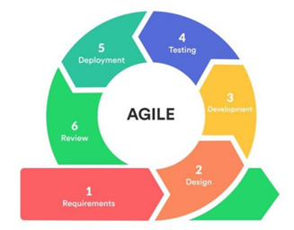
Agile Method Diagram

The researchers have identified that the Agile Methodology is the appropriate Software Development Life Cycle (SDLC) method for the development of a CNN-based facial recognition system for early signs of sleep deprivation in students for health monitoring. According to Pargaonkar (2023), agile methodology provides a continuous feedback loop through iterative development. These cycles allow teams to detect and address difficulties early in the process. Frequent testing and review enable continuous quality improvement yields higher-quality software results. Furthermore, continuous testing and validation are made possible by the method’s iterative nature. Defects and bugs are found early in the development phase, which lowers the expense and work needed to fix problems later on.
In order to train the CNN model, multiple iterations are required to achieve a high percentage of recognition and recall. With the help of an iterative process, the model can converge to an optimal solution where loss is minimized, and the model may perform poorly if the number of iteration processes is only minimal. Pargaonkar (2023), also stated that agile methodology provides a collaborative team environment where it fosters a collaborative and cross-functional team environment, where developers, testers, and quality engineers work together towards a common goal. The researchers also plan to consult and collaborate with experts that deal with sleep deprivation, such as sleep experts or an Ear, Nose, Throat (ENT) doctor.

Project Construction Flowchart
Figure 2
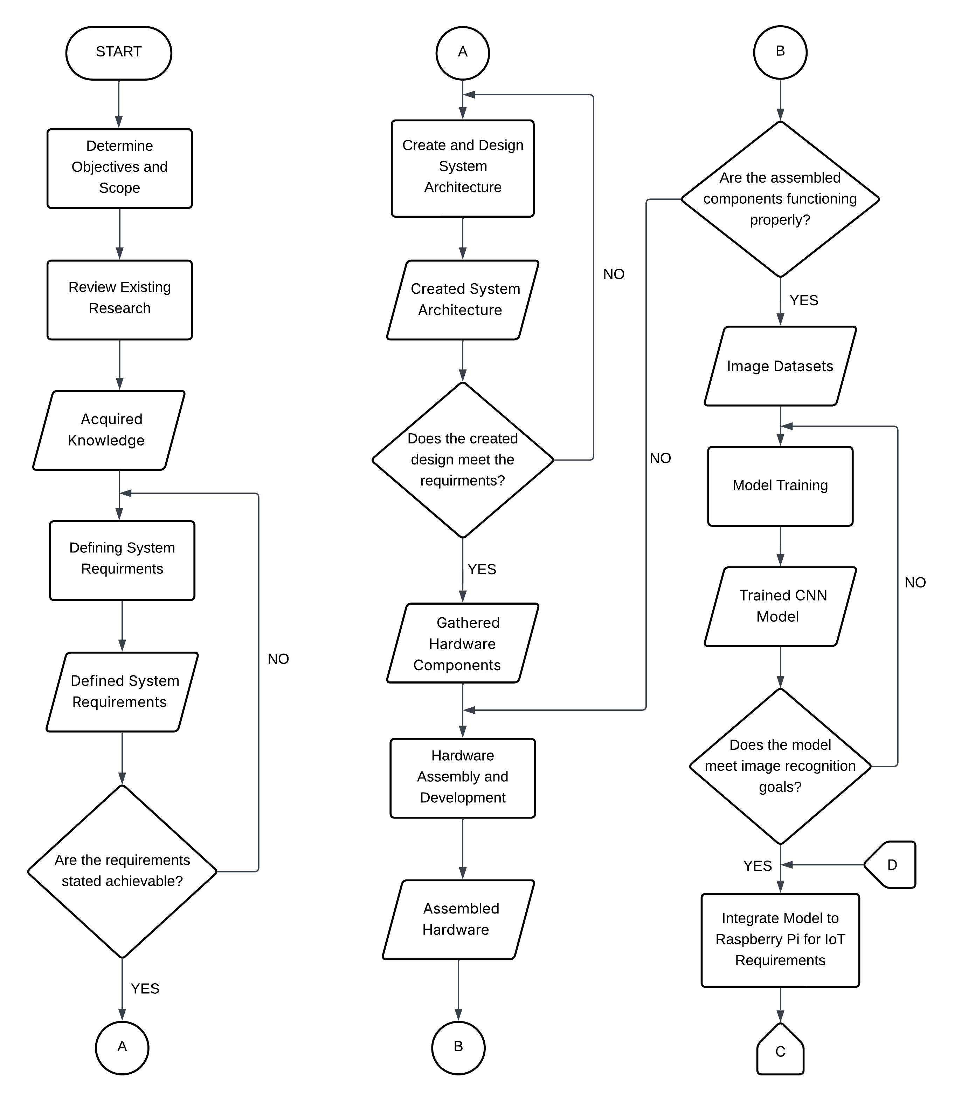
Proposed Project Construction Flowchart

Figure 3
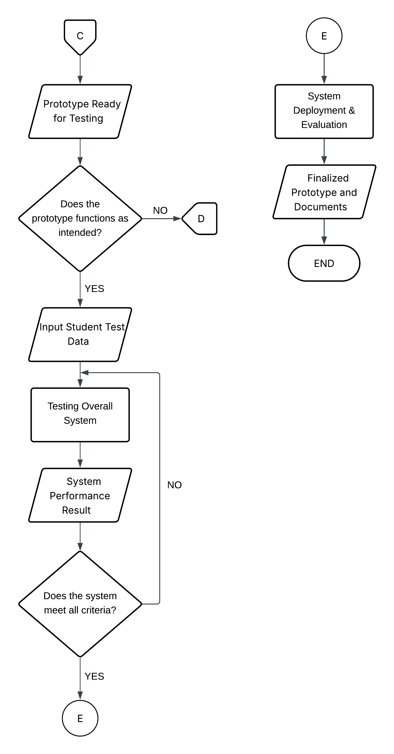
Project Construction Flowchart (Continuation)

The study titled “Development of a CNN-Based Facial Recognition System for Early Signs of Sleep Deprivation in Students for Health Monitoring” intended to boost student well-being by offering timely health monitoring data and an effective way to identify early indicators of sleep deprivation using facial recognition. To provide real-time monitoring, performance assessment, and data analysis for improved health awareness, the system combines image recognition with Internet of Things capabilities.
Figure 2 and 3 presents the flowchart of the project’s construction; it outlines the sequential process for creating a CNN-based facial recognition system intended for health monitoring purposes in order to identify students who are sleep deprived.
1. Determine Objectives and Scope - this procedure establishes the study's aim, objectives, and scope to ensure that specific goals are set for the system’s development.
2. Review Existing Research - To lay the groundwork for the system, this procedure involves reading relevant literature and earlier research on CNN, facial recognition, and health monitoring.
3. Define System Requirements - This procedure determines the system's hardware and software requirements and verifies that all are practical and in line with the project's goals.
4. Create and Design System Architecture - Through the combination of hardware and software components, this process builds the system's overall design while ensuring that it satisfies the required functionalities.
5. Hardware Assembly and Development - This procedure entails constructing and putting together the system's hardware components, making sure each one operates as intended.
6. Training the Model for Image Recognition - Through this procedure, the CNN model is trained to identify face traits that point to the earliest symptoms of sleep deprivation.
7. Integrate Model to Raspberry Pi for IoT Requirement - Through this procedure, the trained CNN model is integrated into the Raspberry Pi, allowing for real-time monitoring and IoT-based functionalities.
8. Test Overall System - This process tests the system to see if it performs as expected and assesses its performance through user experience and from experts.
9. Deploy System - This process sets up the system in the intended setting so that it can be used practically. For this study, researchers will deploy the system on a classroom at the Lyceum of the Philippines University – Cavite campus.
10. Monitoring and Evaluation - This procedure involves ongoing system monitoring and analysis to confirm how well it can identify early facial indicators of sleep deprivation.
11. Finalize Research Documentation - Findings, analyses, and results are combined in this last step to create the research report that will be submitted.
Multiple Constraints Analysis
Plan A:
The system will be developed as a high-performance system to detect early signs of sleep deprivation among the students by facial detection. This starts with the students by pressing the scan button on the touchscreen. The whole process is performed by the Raspberry Pi 5 and the facial images in the Logitech BRIO 4K camera for high-resolution picture. Then the images are run through a model of a Convolutional Neural Network (CNN) which interprets eye openness, facial expression, and skin color pattern to assess student’s wellbeing. The examined outcomes are reflected on the touchscreen in real time and automatically recorded in a web-based application, thereby being able to view the records at the dashboard of the system.
This complete system is very precise, interactive and has an appearance that is ideal for educational institution use. It provides a bigger screen to have improved interaction, advanced processing for the CNN model and crystal-clear images to have accurate detection.
Figure 4
Prototype Design (Plan A)
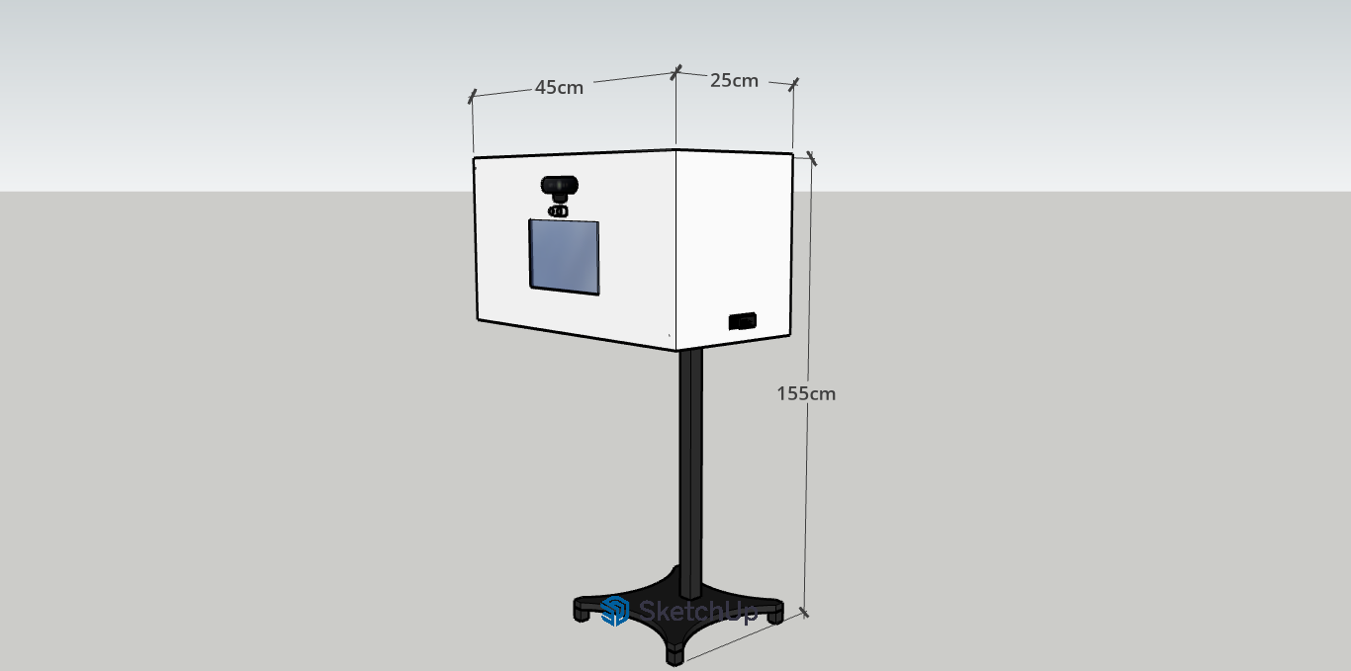

Figure 4 shows the 3D model for Plan A. The casing is 3D printed, inside the case is the Raspberry Pi 5 for data processing and IoT integration. The estimated size of the prototype would be 45cm in length, 155cm in height, and 25 cm in width. The prototype is equipped with a 10.1-inch IPS LCD capacitive touchscreen. For the camera it utilizes the BRIO 4K webcam for capturing high quality image, ensuring accurate detection. The power is supplied via the dedicated power supply for Raspberry Pi 5. Lastly, the system includes an ultrasonic sensor to detect that the student is on the appropriate range for facial capturing.
Figure 5
Registration Page (Plan A)


Figure 5 highlights the registration page for students. This page is dedicated for student account creation. In order for the students to create an account in the system, the page will ask students to provide details including the student’s full name, student ID, and school email address.

Figure 6
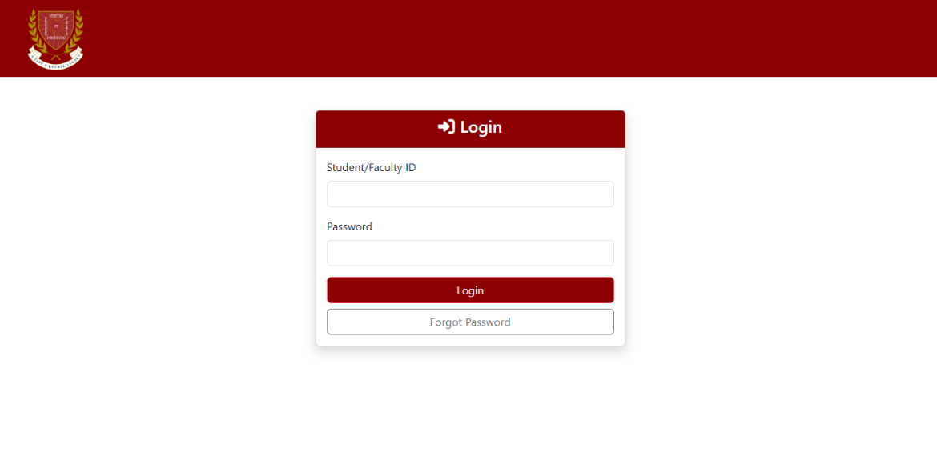
Log-in Page (Plan A)

Figure 6 shows the login page of the system, featuring input fields for Student ID and Password to authenticate users securely before accessing the web application. It also includes a feature “Forgot Password” in the event that a student forgot the password. An email will be sent to the student’s registered email address to recover or change the password.
Figure 7
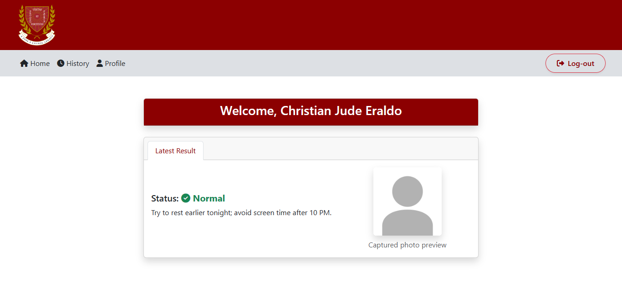
Home Page (Plan A)

Figure 7 presents the home page of the system; it shows the recent result of the sleep deprivation test of the student based on the image captured. The system also has recommendation system that the student can follow. The homepage has other options such as viewing history and student profile.
Figure 8
History Page (Plan A)
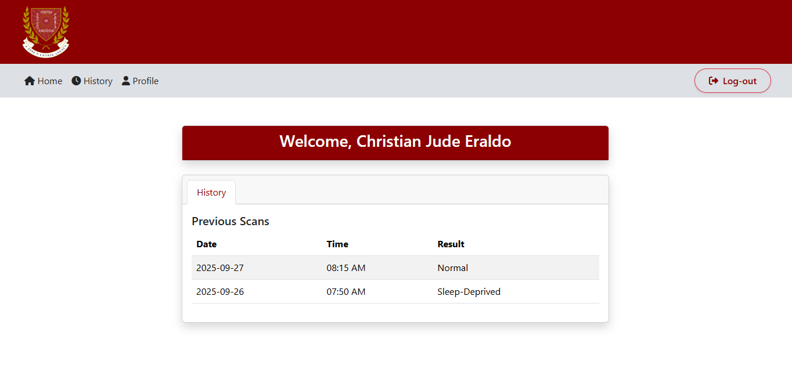

Figure 8 shows the history section of the web application. In this section the students can view the history of the previous scans and track the results for health monitoring. Included in this part are the date, time, and the result of each of the previous scans.

Figure 9
Student Profile Page (Plan A)
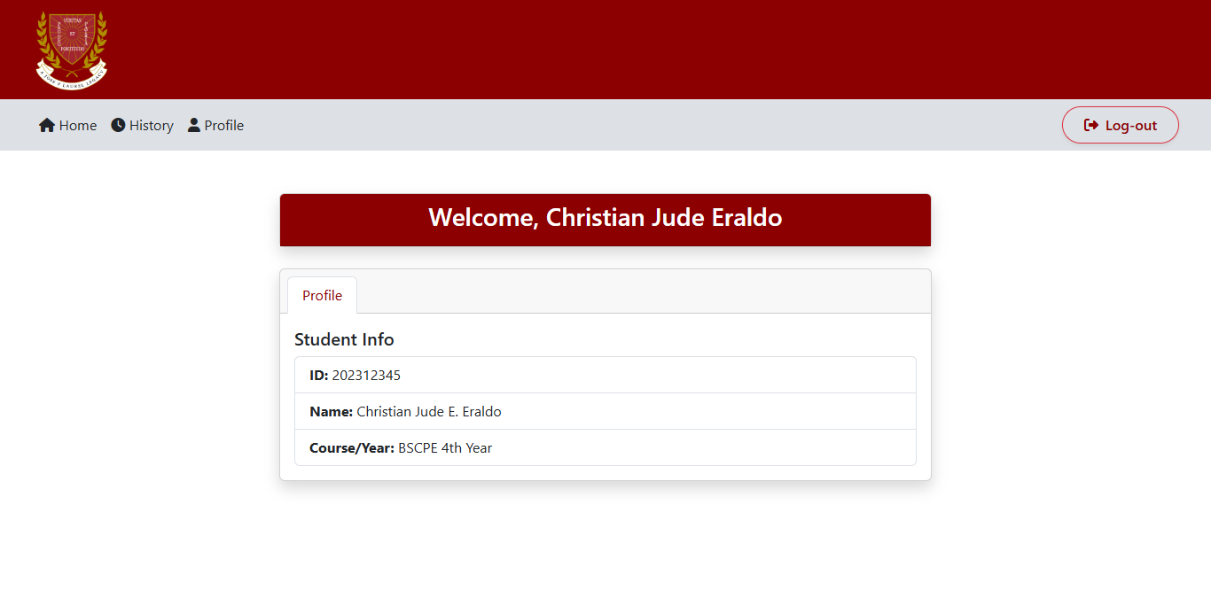
Figure 9 highlights the student profile section displaying key information, including Student ID, full name, and course/year level, with navigation options for Home, History, and Profile, as well as a log-out function for secure access.
Figure 10
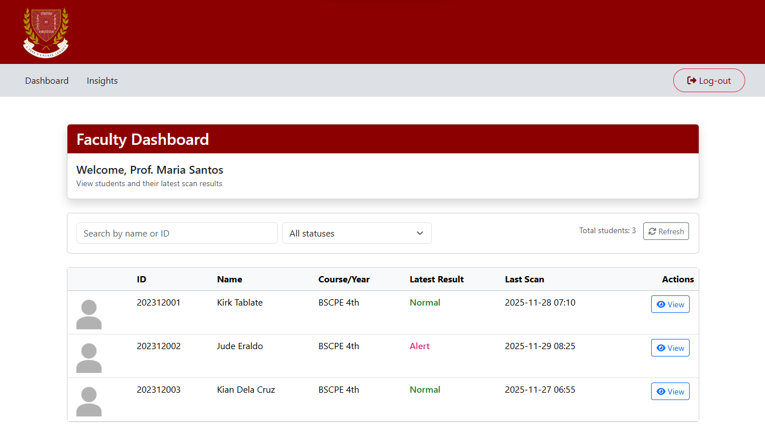
Homepage (Faculty & Clinic Staff)
Figure 10 presents the homepage interface for faculty and clinic staff. It shows the results of the scans of the registered students in the system, it also includes the student ID, name, course, year, and the date of the last scan to give more information.
Figure 11
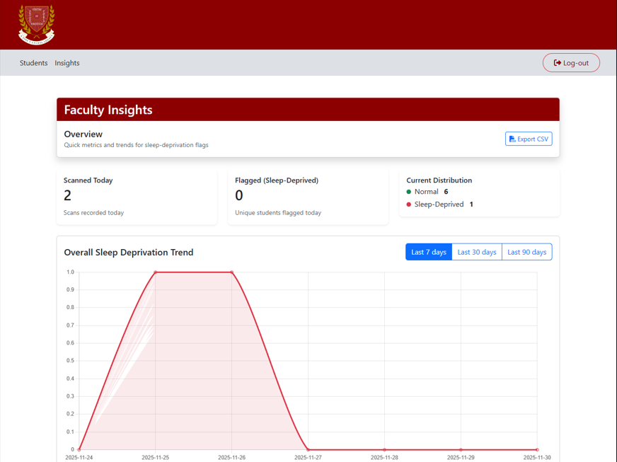
Insight Page (Faculty & Clinic Staff)

The dashboard of Faculty Insights page is shown in Figure 11. It gives an analytical description of sleep-deprivation flags and shows the number of scans and flagged students per day. It also has a distribution summary and a line graph to monitor the overall trend of sleep deprivation over time where staff can visualize trends within a specified date range. The proponents plan to use the website design of figures 10 and 11 for plans B and C.

Figure 12
Admin Homepage
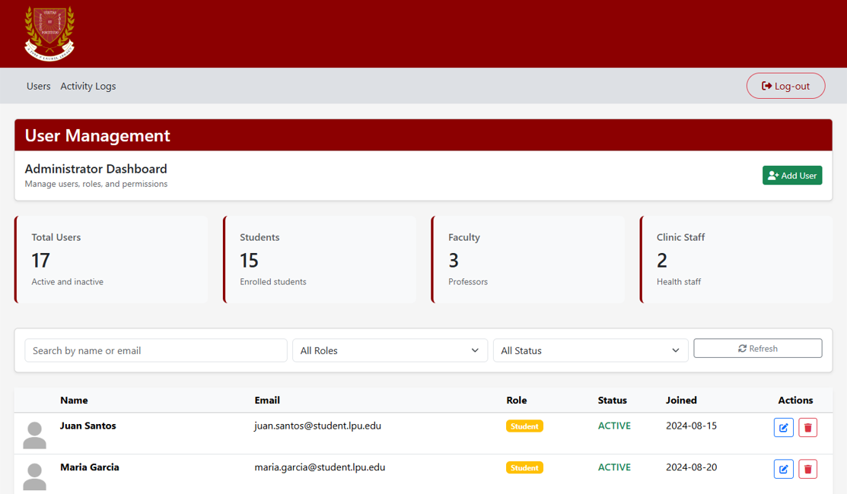

The Administrator dashboard is shown in Figure 12. It presents general statistics for the overall number of registered students, staff and clinic staff. It also displays active users whereby names, email, assigned roles, account status, and join date are listed with available controls to add a new user or to manage an existing user.
Figure 13
Admin Activity Log Page
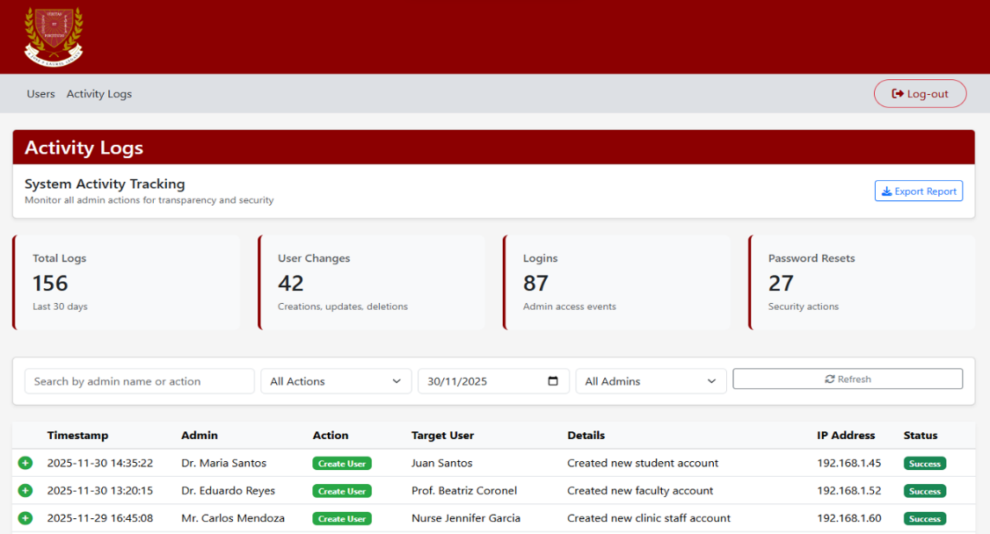

Figure 3 shows the activity logs page in which the system tracking and security monitoring can be done. It draws attention to the most important metrics on the user of the systems, including total logs, the number of changes, and number of logins. The interface also has a comprehensive table of administrative actions where the time, administrator performing the action, the type of action performed, the user being targeted and the IP address are all recorded. The proponents plan to use the website design of figures 12 and 13 for plans B and C.
Table 7
Costing Table for Proposed Plan
Component | Cost (₱)
Raspberry Pi 5(16GB RAM) | 12,000.00
BRIO 4K Webcam | 7,800.00
10.1-inch IPS LCD | 5945.00
64GB microSD Card | 400.00
Raspberry Pi 5 Power Supply | 950.00
GSM Module (SIM7600G-H) | 3000.00
Raspberry Pi 5 Case  3D-printed enclosure | 650.00  2,000.00
Temperature Sensor (Adafruit AMG8833) | 1,900.00
Ultrasonic Sensor  Miscellaneous Components | 100.00  5000.00
Total Cost | 39,745.00

Economic Impact
The suggested plan strikes a balance between long-term value and premium functionality. High processing capability for complicated operations is ensured by the Raspberry Pi 5 (16GB RAM), which lessens the need for regular upgrades. Although they cost more up front, the BRIO 4K Webcam and 7-inch IPS display improve user interaction and functionality. The inclusion of various parts and a 3D-printed shell demonstrate customizable flexibility, which could reduce maintenance costs in the future. Overall, the expenditure is financially justified because it promotes durability, scalability, and high performance which are significant to attain the researchers’ objectives.
Social Impact
The system encourages better engagement by integrating user-friendly components like the 7-inch IPS screen and high-resolution BRIO 4K Webcam, which enhance accessibility and interactivity. The features that are included in the system can boost participation not only from students but from academic and non-academic personnel within the institution. Additionally, by providing a cutting-edge solution, it opens up possibilities for wider community applications including remote health monitoring and collaborative research.
Environmental Impact
Due plan A's components that are long-lasting, energy-efficient, and durable, it exhibits the highest level of environmental responsibility of the three options. Because of its sophisticated technology, it consumes a little more power, but its longer operating life eliminates electronic waste and lowers the need for component replacement.
Sustainability Impact
The system's modular design strengthens sustainability. The high processing capability of the Raspberry Pi 5 limits the frequency of component replacement by extending device lifespan and reducing inefficiencies. Because it is locally produced and customizable with little material waste, the 3D-printed enclosure promotes sustainable practices. The system is sustainable for long-term deployment since the improved hardware can manage larger datasets and more computing power, even though it may require higher power consumption.
Health and Safety Impact
The system offers improved health and safety features due to its enhanced detection and better system integration. Its reliable features enable it to precisely evaluate and notify users of possible symptoms of sleep deprivation. By detecting early indicators of sleep deprivation, the system lowers hazards like accidents and lack of focus throughout daily tasks, hence promoting safety.

Plan B:
The system is designed as a cost-effective and small prototype of detecting the early symptoms of sleep deprivation with the help of facial recognition. The process is still the same as in the first plan. The system is executed with the help of the Raspberry Pi 5, and the Raspberry Pi Camera Module 3 records the face image of the student. The obtained photo will be analyzed by the CNN model that will interpret visual signs of fatigue. The result of the detection is immediately presented on the touchscreen, and the appropriate data were registered in the online database to track and monitor health in real time which can be viewed using the web app.
This set-up provides a lightweight and low-cost portable system with a small scale or prototype level of deployment. It guarantees simple functionality with good performance at minimum expense and power consumption. The smaller screen size, however, and camera quality has restricted its use in the complex environments.
Figure 14
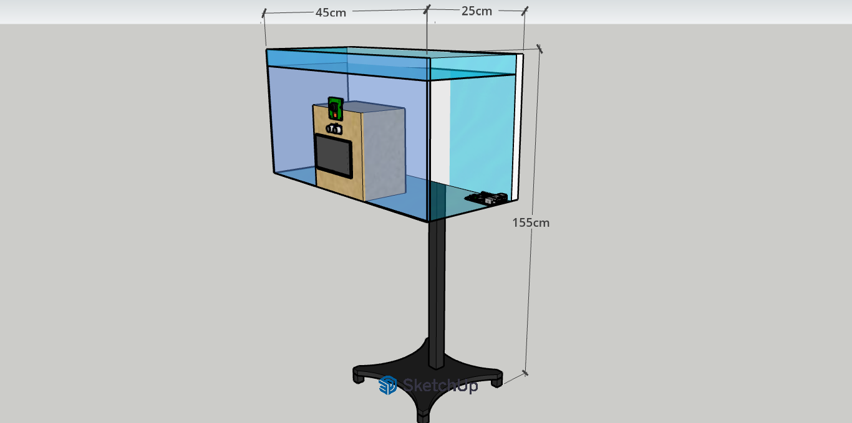
Prototype Design Model B

Figure 14 presents the 3D model for Plan B. This plan's casing is an acrylic case, and it is around the same size as the first. Inside the case is a Raspberry Pi 5 that performs the same functions as the one in plan A. This time the system is equipped with a 7-inch LCD capacitive touchscreen. The prototype’s camera module is the Raspberry Pi camera 3 which can capture decent images. Though it may struggle if the classroom has poor lighting.

Figure 15
Registration Page (Plan B)

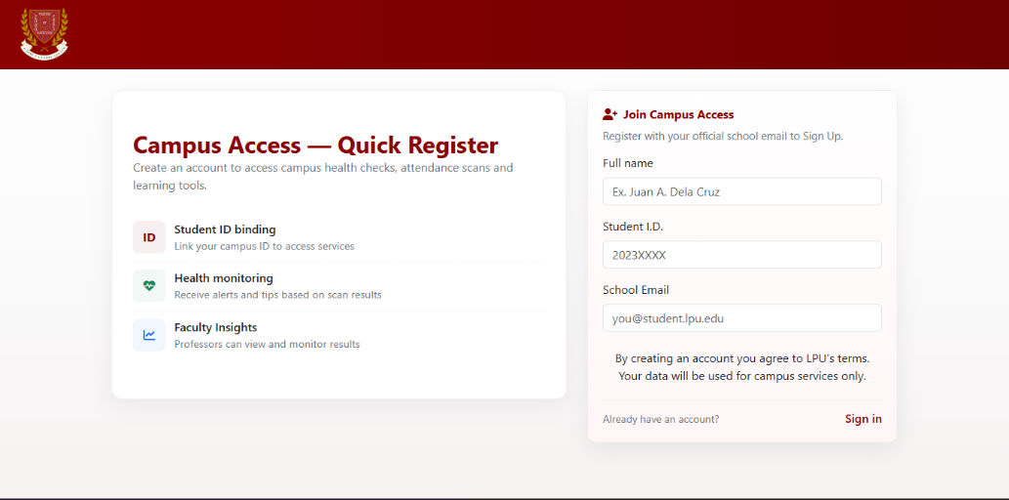

Figure 15 displays the registration page for the students. This interface is designed to allow new students to create an account in the platform by entering essential details such as their full name, student ID, school email address, and password. The layout prioritizes clarity and ease of use, ensuring that students can register without confusion.
Figure 16
Login Page (Plan B)


Figure 16 shows the login page where authenticated access to the system is required. The page contains input fields for the student’s ID and password. A “Forgot Password” option is also present, which allows users to recover their account through their registered school email.
Figure 17
Homepage (Plan B)
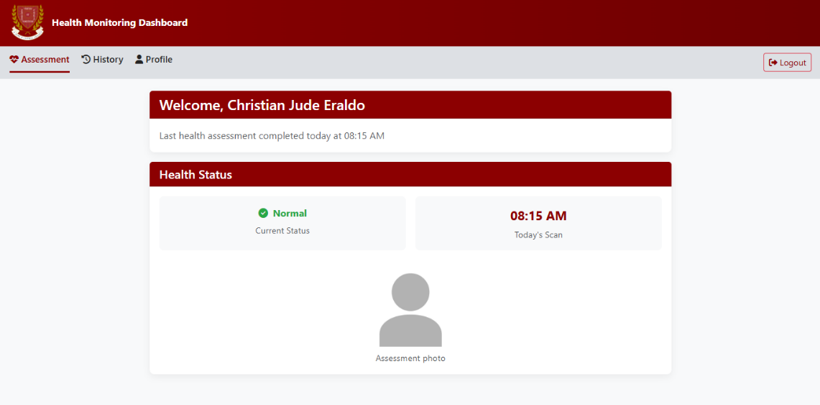

Figure 17 illustrates the homepage of the system. This screen highlights the latest sleep deprivation assessment result based on processed facial images. The “Current Status” box is present to show the system’s most recent assessment result, beside it is the “Today’s Scan” section where users can view the latest scanning session.
Figure 18
History Page (Plan B)
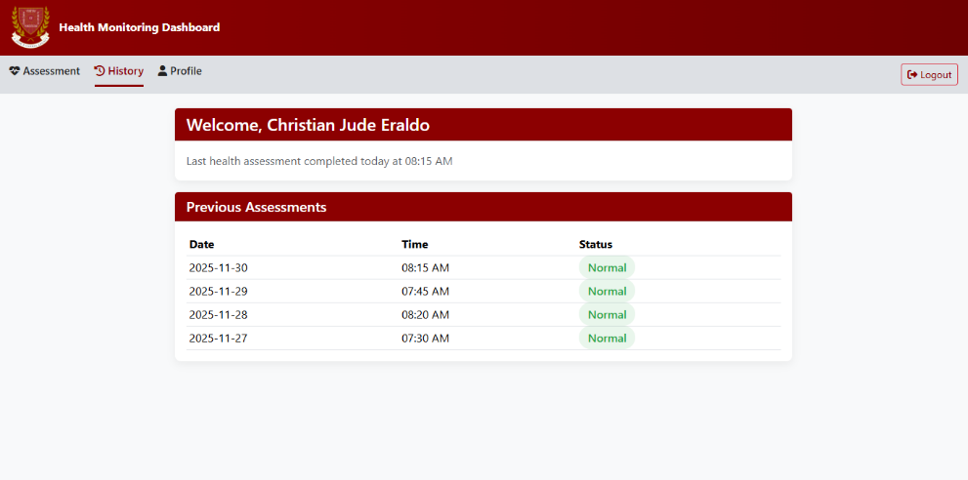

Figure 18 displays the history page where previous scan results are listed in chronological order. Each entry includes the date, time, and corresponding detection output. This allows users to monitor their sleep condition over time.
Figure 19
Student Profile (Plan B)


Figure 19 shows the user profile page containing the student’s basic information such as their name, student ID, course, and related details. Navigation buttons for Assessment, History, Profile, and Logout are provided for seamless movement across different sections of the system. This page serves as the user’s personal information page within the platform.

Table 8
Costing Table for Alternative Plan (Plan B)
Component | Cost (₱)
Raspberry Pi 5(8GB RAM) | 7,600.00
Raspberry Pi Camera Module 3 | 2,200.00
7-inch LCD display | 3,290.00
32GB microSD Card | 355.00
5V/3A–5A Power Bank w/ PD | 1000.00
GSM Module (SIM7600G-H) | 3000.00
3D-printed case  Acrylic Case | 300.00  500.00
Temperature Sensor (MLX90614-NCIR) | 1,500.00
Ultrasonic Sensor  Miscellaneous Components | 100.00  5,000.00
Total Cost | 24,845.00

Economic Impact
In comparison to the suggested design, the alternative option is much more cost-effective, reducing the overall cost by nearly half. Student researchers can use it because it employs inexpensive parts like the Raspberry Pi Camera Module 3 and a smaller touchscreen. However, there may be performance and scalability trade-offs associated with the smaller investment.

Social Impact
The system's social impact is modest because it still offers essential health monitoring features at a reduced cost, making it more affordable for small-scale or academic use. In contrast to higher-end configurations, the smaller screen and average camera quality could significantly limit user interest.
Environmental Impact
This plan provides the least amount of immediate energy consumption due to its core components' low power requirements. However, it is more likely to wear out quickly and eventually need to be replaced due to the use of less expensive and durable materials, which eventually increases the amount of electronic waste produced.
Sustainability Impact
In terms of energy consumption, the alternative plan is more sustainable since the components for this plan consumes less power. However, if the project grows, the smaller storage and lower processing capacity might necessitate earlier modifications, which would impact long-term sustainability.
Health and Safety Impact
The system offers a simple yet useful feature for monitoring health. It may be less accurate because of simpler hardware, but it can still alert people to possible sleep deprivation. While still present, the safety benefits are not as sophisticated as those of the higher-spec plan.
Plan C:
Plan C is a balanced and steady system that has focused on both the usability and reliability of the system in detecting sleep deprivation. It begins with the student pressing on the display that has a size of 7 inches to start the scanning process. The Raspberry Pi 5 takes care of the operations of its system, the Logitech C920 HD webcam records clear facial images to analyze. Physical signs of drowsiness and reduced alertness are detected by processing these images with a CNN-based model. The processed results are displayed on the touchscreen and automatically updates with the web application, which allows for real-time monitoring.
This model is a mid-range option with a better image display, user interaction and stability. It offers an adequate balance between affordable price, features, and longevity. It is however less powerful than Plan A in processing and detailing images, and also not as portable as Plan B, which makes it a reliable intermediate choice where academic or institutional testing is desired.
Figure 20
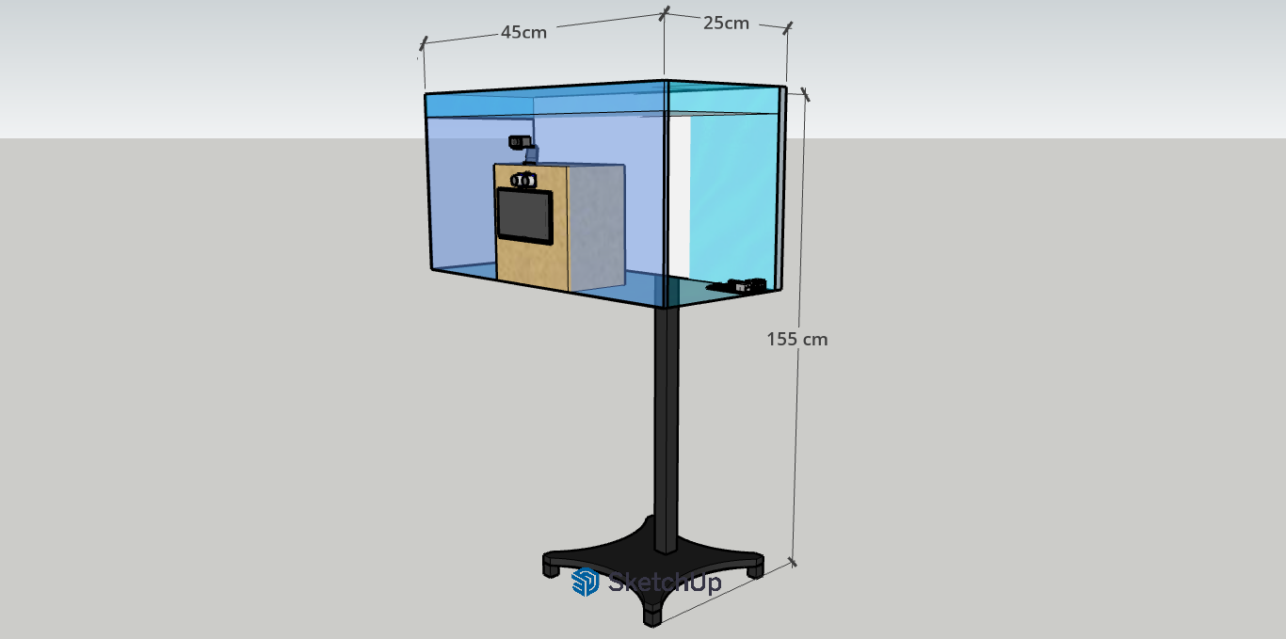
Prototype Design (Plan C)

Figure 20 showcases the 3d model of Plan C. The size, design, and some components are identical to Plan B, however minor upgrades can be noticed. The camera module for this plan is better when compared to Plan B, making images more detailed. This can be considered as the mid-range plan between the three.
Figure 21
Registration Page (Plan C)
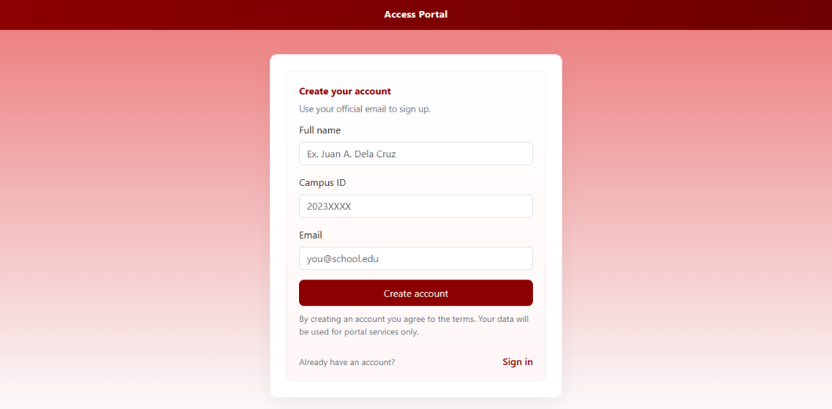

Figure 21 presents the registration page for Plan C that enables students to create an account in the sleep deprivation monitoring portal by entering their full name, campus ID, and institutional email address.
Figure 22

Login Page (Plan C)

Figure 22 shows the login page it will be used by registered students to securely access the system using their campus ID and password, with options for password recovery and new account creation.
Figure 23
Homepage (Plan C)
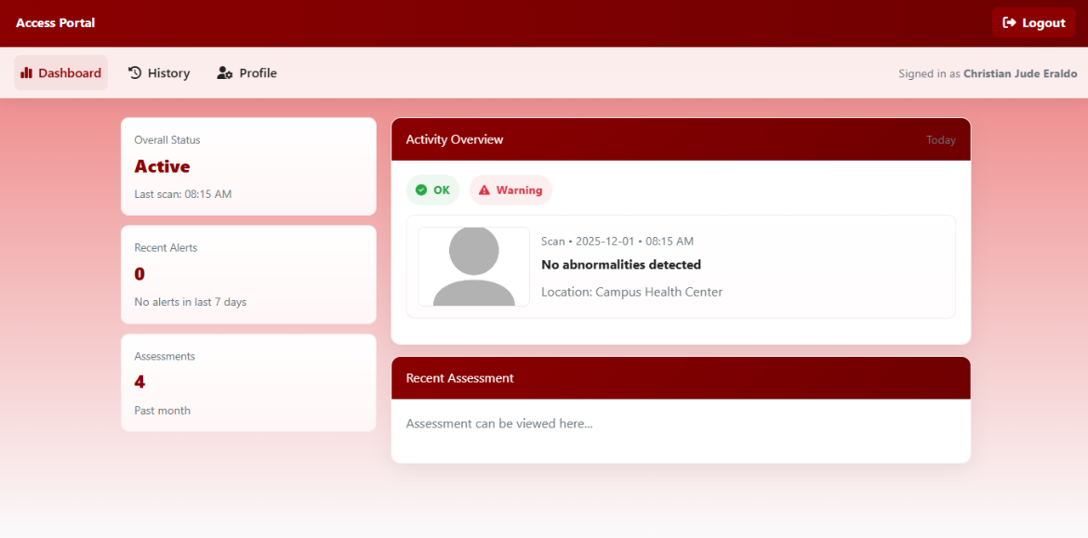

Figure 23 highlights the homepage it presents an overview of the student’s current status, displaying the latest facial scan result, recent alerts, and the total number of assessments conducted.

Figure 24
History Page (Plan C)
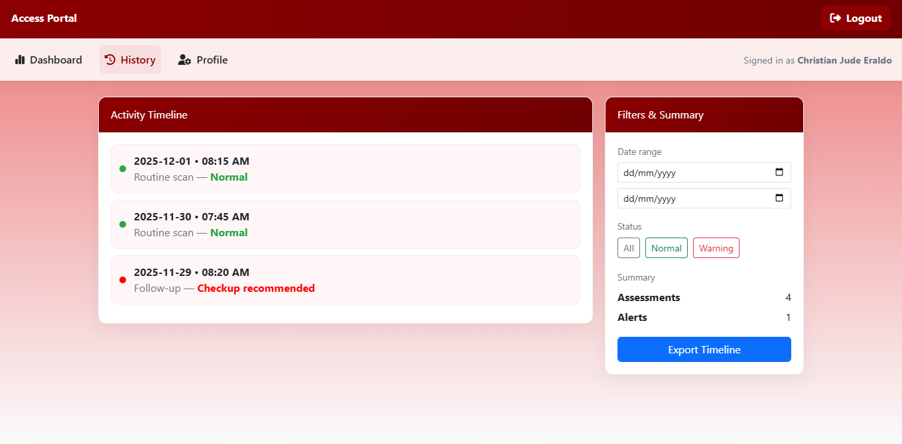

Figure 24 presents the history page shows a chronological list of previous scans, including the date, time, and corresponding status, with filters for date range and result type, as well as an option to export the timeline.
Figure 25
Student Profile (Plan C)
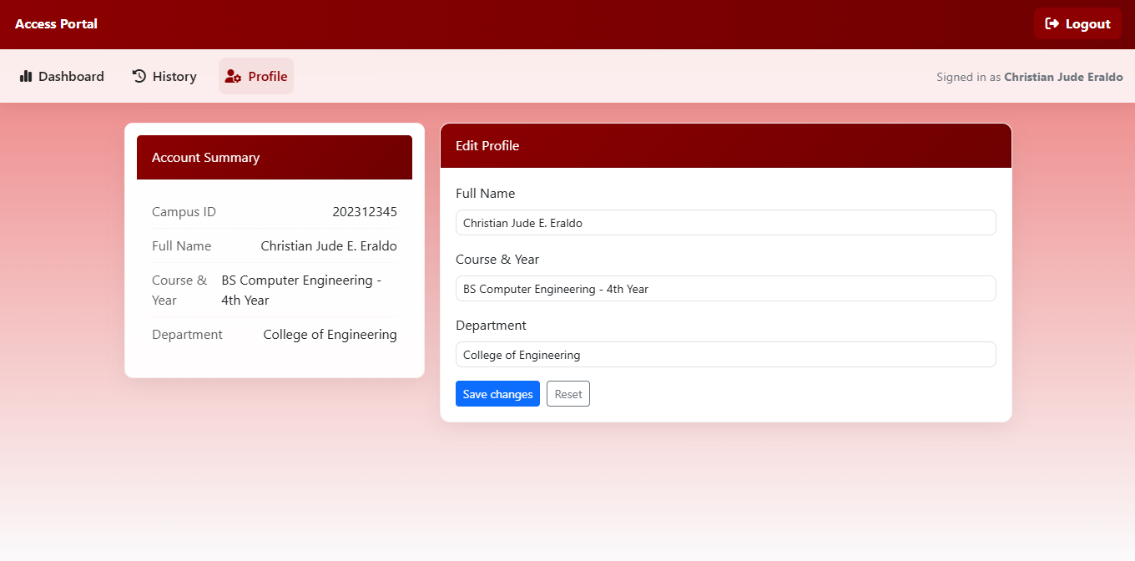

Lastly, Figure 25 shows the student profile page that contains the user’s basic information-campus ID, full name, course, year level, and department-and provides editable fields for updating these details.
Table 9
Costing Table for Alternative Plan (Plan C)
Component | Cost (₱)
Raspberry Pi 5(8GB RAM) | 7,600.00
Logitech C920 Webcam (1080p) | 4,800.00
7-inch LCD display | 3,290.00
32GB microSD Card | 355.00
Raspberry Pi Power Supply | 950.00
GSM Module (SIM7600G-H) | 3000.00
Raspberry Pi Case  Acrylic Enclosure  Ultrasonic Sensor | 400.00  1000.00  100.00
Temperature Sensor (MLX90614-NCIR) | 1,500.00
Miscellaneous Components | 5,000.00
Total Cost | 27,895.00

Economic Impact
In contrast to Plans A and B, the second alternative offers dependable operation at a significantly lower cost than Plan A while maintaining better performance than Plan B. This makes it economically feasible for researchers or organizations with limited funding, guaranteeing the project's viability while being able to perform the task it is intended to do.

Social Impact
Although Plan C enables researchers with limited budgets to implement the system, its mid-range hardware may not provide the same accuracy and responsiveness as Plan A. Plan C offers moderate social benefits but falls short of the wider impact achievable through Plan A. The consistency of the system's detection of sleep deficiency may be impacted by slower processing speed and lower-quality camera output.
Environmental Impact
Plan C strikes a balance between energy efficiency and performance, resulting in a moderate environmental impact. It has a reasonable environmental profile since its mid-range components are more robust than those of Plan B and use less power than those of Plan A. In contrast to Plan A's superior hardware, Plan C's components still have shorter lifespans, which could eventually result in more waste accumulation.
Sustainability Impact
This plan uses energy-efficient components, its mid-tier hardware might wear out more quickly and need to be replaced sooner than the premium components in Plan A.
The mid-range parts in Plan C have a decent operational life while using less energy and costing less to develop. For low-maintenance functioning and long-term environmental responsibility, Plan A is still the more sustainable investment, even though Plan C offers short-term cost savings.
Health and Safety Impact
Plan C keeps the same health and safety criteria as Plan A by adding a secure enclosure and a reliable power supply. This makes sure that the system may be used safely in classrooms. However, its lower-quality camera may decrease detection accuracy, that can limit the reliability of the system in detecting students with sleep deprivation.
Impact Analysis
The researchers used artificial intelligence (AI) to score each plan in order to assess the impact analysis of Plans A, B, and C. The assessment of the AI was then compared with the independent evaluation carried out by the researchers. Plan A is the better choice, according to the results, which indicated that both approaches came up with the same preferred option.
Table 10
Result of Impact Analysis
Impact Area | Weight | Plan A | Plan B | Plan C
Economical | 0.25 | 4(1.00) | 5(1.25) | 5(1.25)
Social | 0.15 | 4(0.60) | 3(0.45) | 3(0.45)
Sustainability | 0.20 | 4(0.80) | 3(0.60) | 4(0.80)
Environmental | 0.20 | 4(0.80) | 3(0.60) | 3(0.60)
Health and Safety | 0.20 | 5(1.00) | 3(0.60) | 4(0.80)
Total Score | 1.00 | 4.20 | 3.50 | 3.90

Table 10 shows that Plan A is the most practical, sustainable, and impactful choice, with a total score of 4.20. Since plan A got the highest score among the options the researchers have decided to go with the said plan. The proponents believed that this is the best choice among the three as it guarantees long-term dependability, consistent accuracy in identifying early signs of sleep deprivation, and optimal system performance.

Table 10
Multiple Constraints Analysis Rubrics
Criteria | 5  Excellent | 4  Good | 3  Satisfactory | 2  Poor | 1  Very Poor
Economical | Cost is clearly within budget (≤ ₱30,000). Very cost-efficient for its features. | Cost is within budget (> ₱30,000–₱35,000). Benefits justify the expense. | Cost is near the limit (> ₱35,000–₱40,000). Value is acceptable but average. | Cost exceeds preferred budget (> ₱40,000–₱45,000). Benefits are limited for the price. | Cost is far above a reasonable student budget (> ₱45,000). Not cost-effective
Social | Widely accepted by students and staff. Easy to use and non-intrusive. | Generally accepted. Minor hesitation or adjustment needed. | Mixed acceptance. Some users are hesitant or uncomfortable. | Low acceptance. Many users avoid or dislike using the system. | Socially unacceptable. Creates distrust, stigma, or negative reactions.
Sustainability | Durable and modular. Easy to repair, upgrade, and scale. | Can last several years with maintenance. Moderate scalability. | Suitable mainly for pilot use. Scaling needs noticeable changes. | Hard to maintain or upgrade. Scaling is very difficult. | One-time prototype only. No realistic long-term use.
Environmental | Very low power use. Minimal materials and e-waste. | Low to moderate power use. Limited environmental impact. | Average power and material use. No specific eco-measures. | High power use or many non-reusable parts. Noticeable impact. | Very high power use and e-waste. No regard for environmental effects.
Health and Safety | Accurately supports early sleep-deprivation detection. Physically safe and privacy-aware. | Mostly accurate and safe. Only minor health or privacy concerns. | Limited health benefit due to moderate accuracy. Still physically safe. | Frequent wrong results that may confuse users. Some safety or placement issues. | Unsafe or harmful. Very inaccurate or risky in design or data handling.

System Model / Project Model
Figure 26
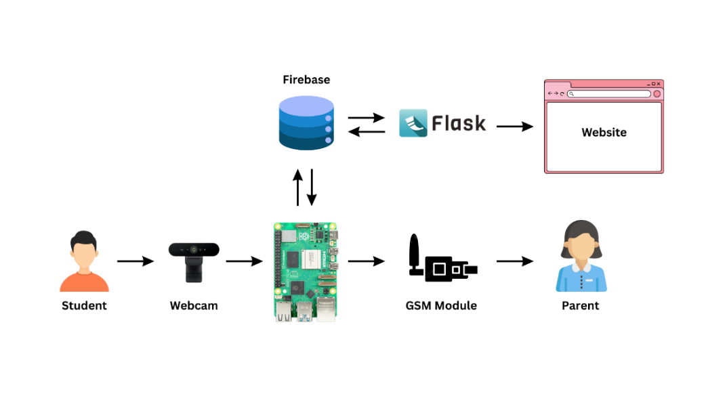
System Model of the Recognition System

Figure 26 illustrates the suggested system design. The BRIO 4K camera takes facial photos, which are then processed by the Raspberry Pi 5 using the CNN MobileNetV3 model to detect indicators of sleep deprivation. Flask acts as the middleware, connecting the hardware to the software interface and delivering processed data to the Firebase cloud database. The web-based dashboard pulls this information from Firebase, allowing students to examine outcomes and health advice in real time.
System Flowchart
Figure 27
Proposed System Flowchart
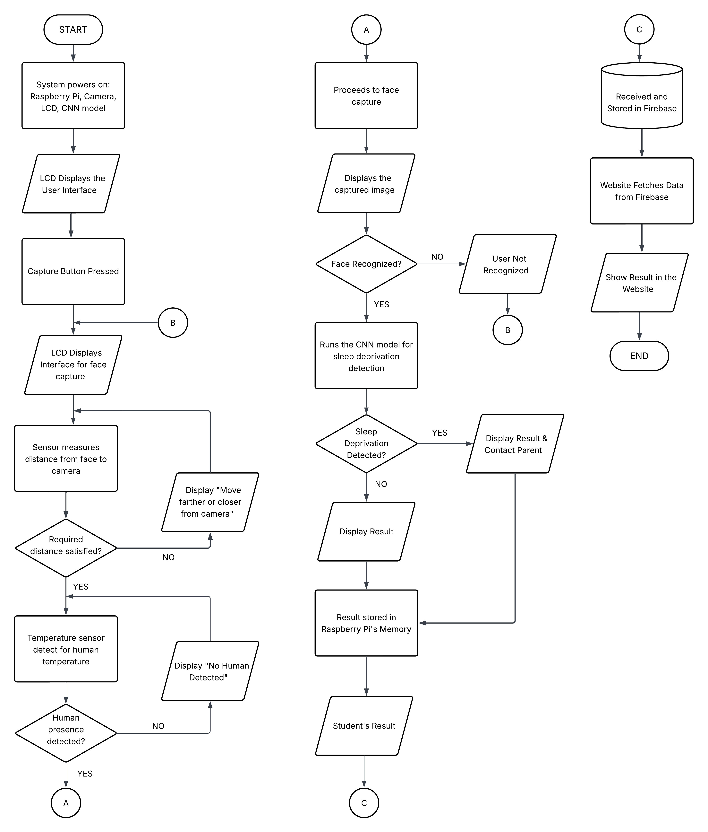
Figure 27 shows the suggested system flowchart. When the Raspberry Pi boots up, it initializes all of the necessary components, including the camera, LCD display, and CNN model. Next, the system waits for the user to push the capture button. When pressed, the camera takes an image of the student's face, which is then processed by the CNN model for facial recognition. If the system fails to detect the face, a message on the LCD screen will display that the student is not recognized, the process repeats, urging the user to retake the image. When the face is properly recognized, the CNN model moves on to the next stage, which is the sleep deprivation detection. The model examines the student's facial characteristics to see whether they display signs of sleep deprivation. If the model detects sleep deficiency, the system presents the result and the suitable advice on the screen. If no sleep deprivation is observed, it returns a normal result. In both situations, the output is saved in the Raspberry Pi's memory, identified as the student's result, and then sent to Firebase for centralized storage. The website retrieves this information from Firebase and presents the result on the student's profile page on the website, completing the procedure.
Website Flowchart
To better comprehend the website's flow, a website flowchart is provided, which includes information on the page structure, navigational pathways between different sections, user interaction points, and the overall flow users take while accessing the contents of the website.

Figure 28
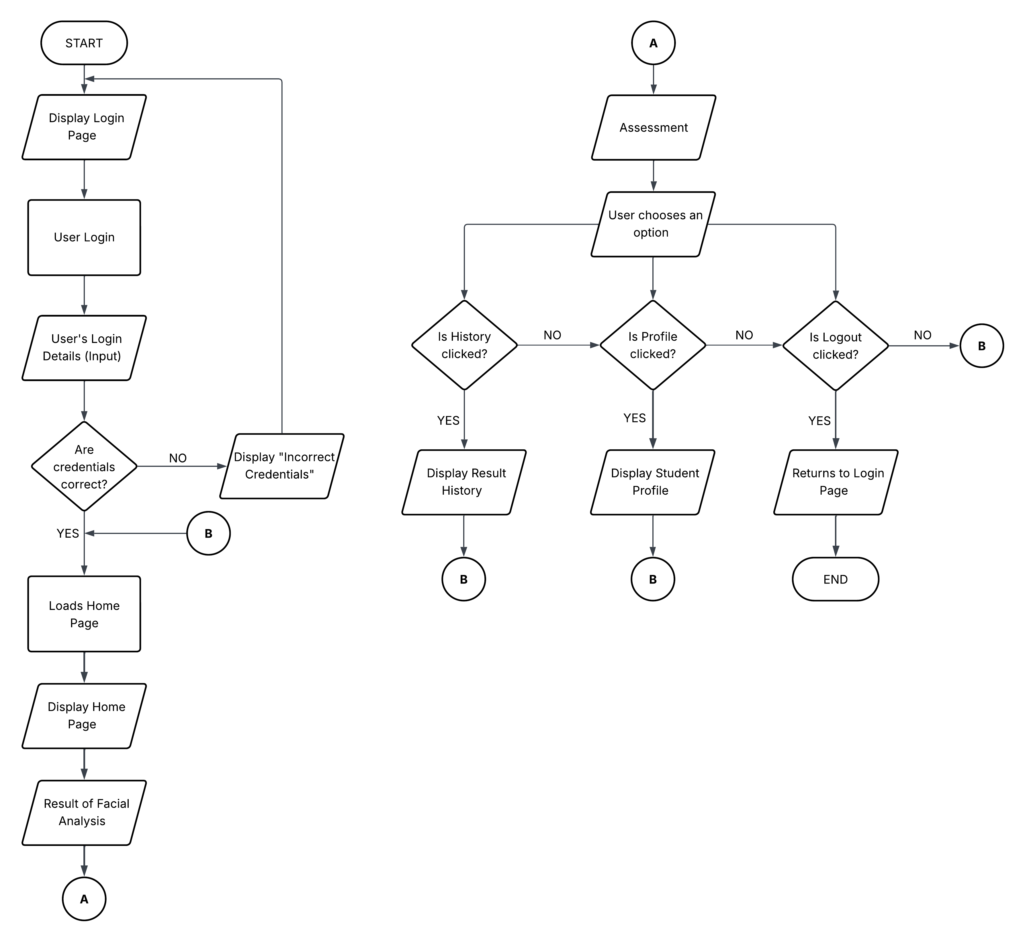
Website Flowchart

The CNN-Based Facial Recognition System for Early Signs of Sleep Deprivation in Students has a website flowchart that is displayed in Figure 28. It shows the sequence of user interaction with the system starting with the process of logging in to the system up to accessing different features of the website. The user enters the details of the login credentials (ID and password) then the system checks if the details are correct. In case of inaccuracy of the credentials, there will be an error message stating to double check the inserted login details. If successfully logged in to the system the user will be redirected to the Home Page, where the facial analysis result and recommendations are displayed. Inside the same page, it gives the user three primary options to view the result history, view student profile, or to log out. The choice of each option takes one to its page and after completion, the user can get back to the Home Page. After clicking the Log Out button, the user will be navigated back to the Login Page. Such flow guarantees good navigation flow, efficient information retrieval and safe management of user sessions within the website.

Figure 29
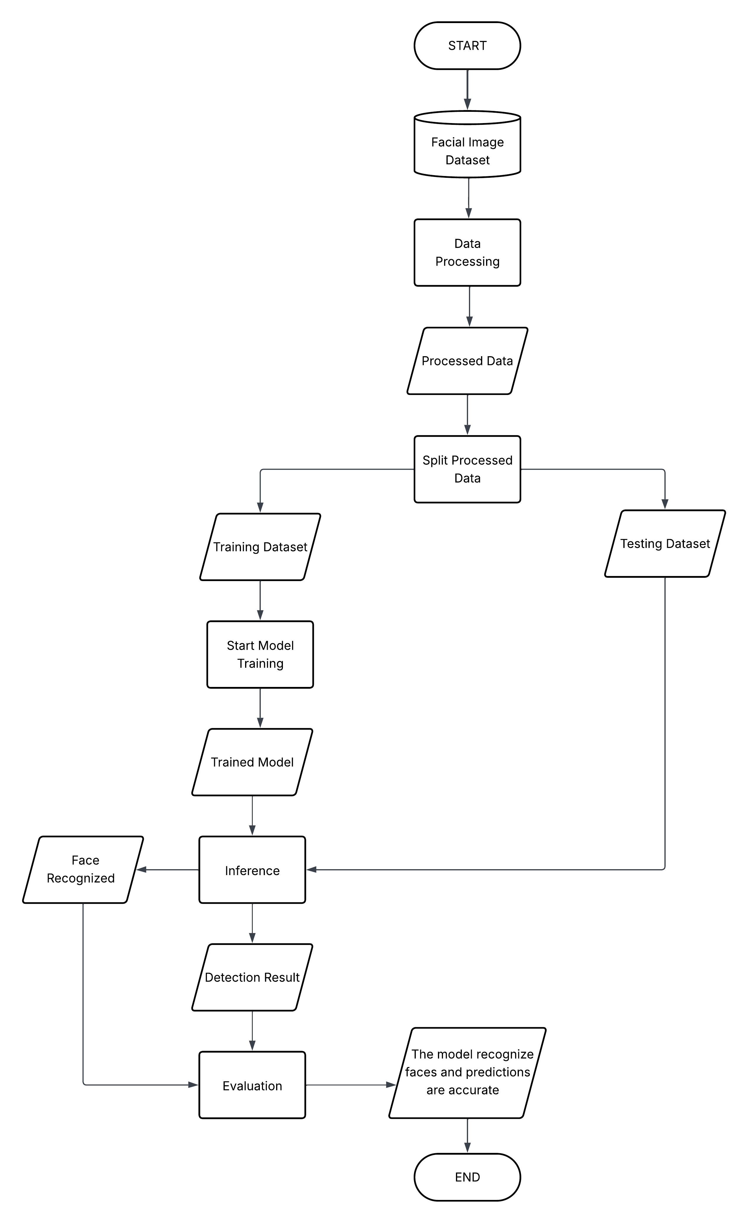
Flowchart of Prediction Model

Figure 29 shows the flowchart of the proposed prediction model, which uses the CNN MobileNetV3 architecture. The method begins with utilizing a facial image dataset, which will be used to train and evaluate the model. To maintain consistency and increase model accuracy, these photos are subjected to a number of data preprocessing procedures, including scaling, normalization, and augmentation. After processing, the dataset is separated into two: the training and testing datasets. The training dataset is utilized to start the model training phase, during which the CNN MobileNetV3 learns to extract and categorize characteristics from facial photos. After finishing, a trained model is produced and moves on to the inference phase. The testing dataset is used to assess the trained model's facial recognition and sleep deprivation detection functionality during inference. Following that, the model produces detection results, which are evaluated during the evaluation stage in order to measure performance indicators including recall, accuracy, and precision. The model verifies facial identification and keeps generating accurate detection results if it can identify a face.

Context Flow Diagram
Figure 30
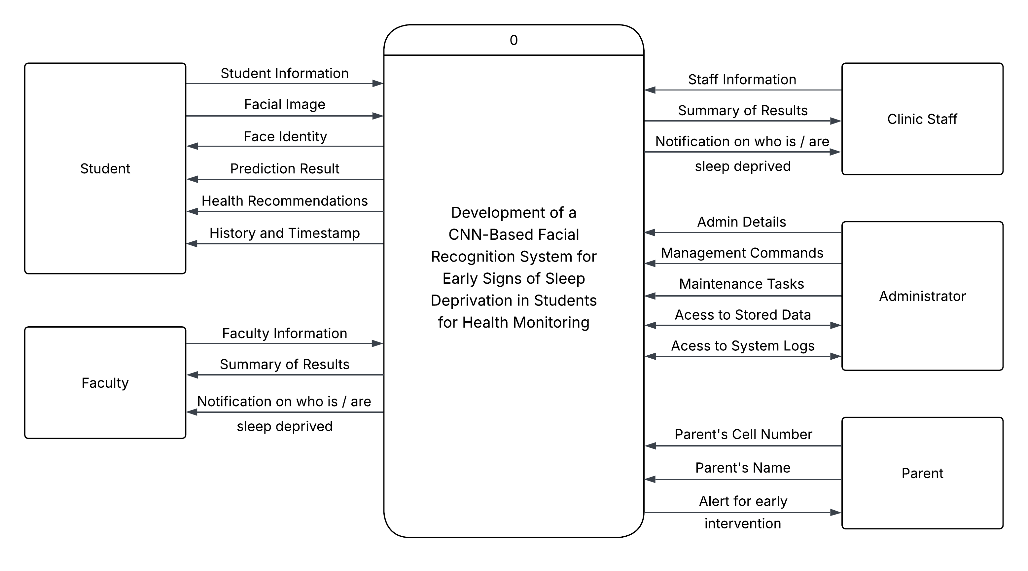
Proposed Context Flow Diagram

Figure 30 shows the context diagram for the CNN Based Facial Recognition System which includes interaction with the student, faculty, clinic staff, and administrator. Input data like student details and facial images to the system, produces outputs including sleep deprivation prediction, health tips, and past records. Faculty members can get an overview of reports and notifications on students that have been identified as sleep deprived by the system. Clinic staff have the same access as the faculty members for intervention purposes. The student’s parent or guardian may also receive SMS alert if the system have assessed that the particular student shows signs of sleep deprivation. The admin has the full control of the system such as managing user access, do maintenance, and access stored data and system logs. Also, the diagram presents the system’s role as a central player in student well-being monitoring and institutional health care.
Data Flow Diagram
Figure 31
Proposed Data Flow Diagram
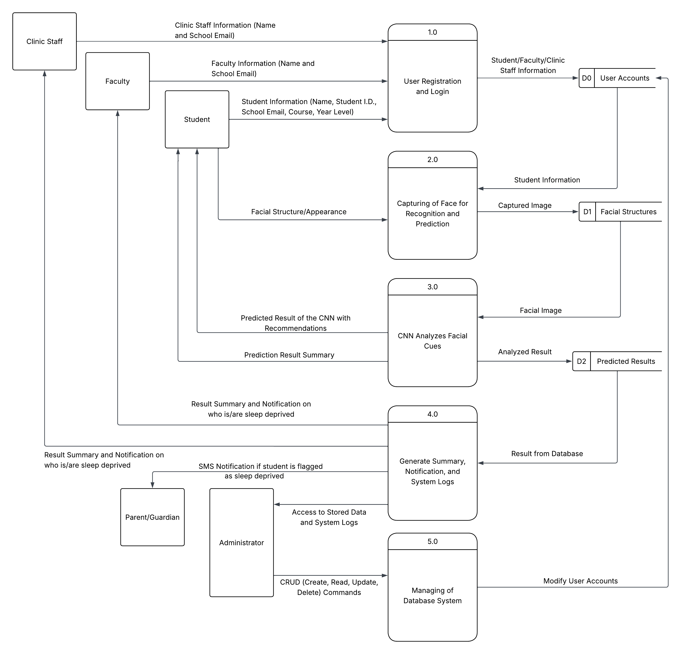
Figure 31 represents the Level 1 Data Flow Diagram of the proposed system and depicts the internal processing steps along with the flow of data from outside entities like students, faculty members, clinic personnel, and administrator into the system. The first step in the system involves registering users and logging-in, storing student, faculty, and clinic personnel account information in a user accounts database. Next, the system records each student's facial image for recognition purposes and stores the recorded image in a facial structures data storage. Each student's facial structure is analyzed by the CNN model to identify the facial expressions and generate predictions based on facial cues and record the results in the predicted results database. All of the collected results are compiled to create summaries, notification and log entries that will be shared with the faculty, clinic staff and administrators to provide them with a means to monitor and intervene. Additionally, if the system assessed that a student is sleep deprived, it will send an SMS alert to the registered parent/guardian. Finally, the administrator provides access to all of the databases through CRUD operations and ensures that all data is properly stored, retrieved and maintained within the system. In summary, Figure 17 demonstrates the different processes involved and the flow of data in the proposed system.
Instruction Guidelines and Policy
To ensure smooth participation from users, the following instructions, guidelines, and policy will be displayed to inform users beforehand and as a constant reminder:
Instructions
- Proceed to the designated classroom with the installed system.
- Stand within the camera’s field of view for facial capture.
- Avoid covering the face with accessories or unnecessary gestures.
- The system will automatically process your facial image.
- Check results through the official web-based application.
Guidelines
- System Use
- For registered students and authorized faculty only.
- User Conduct
- Students must cooperate and avoid disrupting the scanning process.
- System Accessibility
- Results can only be accessed via the official web dashboard.
- Testing Sessions
- Use requires prior notice and informed consent.
Policy
- Data Privacy
- Facial images and health data are confidential and stored securely.
- Accountability
- Students must maintain accurate account information.
- Misuse Prevention
- Tampering or unauthorized access is prohibited.
- System Reliability
- Maintenance may cause downtime; false positives/negatives are possible.
- Ethical Compliance
- Participation is monitored under institutional ethics guidelines.
Test Requirements
To ensure that the CNN-based facial recognition system satisfies all specified goals, parameters, and expected results, thorough testing, assessment, and validation are necessary. The testing step will be crucial for detecting functional problems, assessing the precision of detection, and confirming that the system's operation matches the requirements of its design. These tests will ensure that the monitoring procedure is effective, precise, and easy to use while confirming the system's credibility, quality, and dependability in identifying early indicators of sleep deprivation.

Test Planning
The researchers will subject the system through a number of systematic testing after integrating all the key parts. The accuracy of the CNN facial recognition model will be tested, along with the integration of the trained model into the Raspberry Pi and the monitoring features on the webpage. To assess the system's resilience and consistency, it will also be tested with various facial inputs and lighting conditions. Large-scale deployment testing may not be possible due to time constraints, but repeated short-term trials will be carried out to verify steady performance, reliable detection, and appropriate data recording. The goal of this planning stage is to guarantee that the system runs smoothly and gives students insightful health monitoring feedback.
Test Hardware Components
The hardware testing phase will systematically validate the functionality and reliability of the system's physical components. This involves stress-testing the Raspberry Pi for processing stability, evaluating the high-resolution camera's performance under various lighting conditions, and ensuring the power supply provides consistent voltage. Finally, the fully assembled prototype will undergo a continuous endurance test to confirm that all parts work together seamlessly without overheating or failure, ensuring the device is physically robust and prepared for deployment in a real classroom environment.
Test for Detection Accuracy and Precision
The system's performance will be evaluated through a two-phase process focusing on both facial recognition accuracy and the precision of sleep deprivation detection. First, the facial recognition model will be tested against a dataset of enrolled students under varied conditions like different lighting and angles to measure its identification accuracy. Second, the sleep deprivation model's effectiveness will be validated by comparing its automated classifications of facial cues (such as dark circles etc.) against a baseline assessment provided by an ENT Specialist to calculate key performance metrics, thereby rigorously confirming the system's reliability.
The following formula will be used to test accuracy and precision:
$$Accuracy= \frac{TP+TN}{TP+TN+FP+FN}$$

$$Precision= \frac{TP}{TP+FP}$$
Test for Usability and Accessibility
The user experience will be measured through Likert-scale questionnaires, which will be administered after the respondents utilize the system. The test will evaluate ease of use, clarity of interface, responsiveness, and accessibility under different conditions, such as lighting and facial features. Results will determine whether the system provides an accessible and user-friendly monitoring experience.

Test for Functional Operability
This test aims to ensure that all system components, including the Raspberry Pi, camera, CNN model, and database, function properly when integrated. Trial sessions will be conducted in classrooms to confirm that the system can consistently capture, preprocess, classify, and display results in real time. Observations will also track reliability over repeated sessions, checking for stability and performance issues.
Validation Procedures
After usability, accessibility, and operability tests, a comprehensive validation will be conducted to confirm that the system meets requirements for accuracy, recall, and F1-score, as well as user satisfaction and reliability.
Expert Validation:
- An IT specialist will verify the technical accuracy of the CNN model and integration.
- A medical professional specifically a somnologist or an otolaryngologist (ENT specialist) will validate the facial indicators of sleep deprivation.
User Validation:
- Students will provide feedback through structured questionnaires and observation sessions.
- Their input will ensure that the system is practical and beneficial in real-world classroom settings.
Together, expert and user validation will confirm that the system is effective, reliable, and ethically compliant.
Evaluation Procedures
This procedure aims to assess the acceptability of the system, based on the proponents’ chosen criteria set by the ISO/EIC 25010. The following criteria to be evaluated are as follows, Functional suitability, performance efficiency, reliability, and usability. Once the students are done on facial capture and result viewing a 5-point Likert-scale questionnaire will be given to the respondents to answer. The functional suitability will be checked by determining whether the system has all the desired functions. The efficiency of performance will be calculated using the processing speed of the system, its responsiveness and the detection capability of the system. Reliability will be measured according to precision and accuracy of classification results of the CNN model. Lastly, usability will be determined by the user’s comments for general user experience.
Table 11
5-Point Likert Scale for Acceptability
Points | Category | Mean
5 | Strongly Agree | 4.21 – 5.00
4 | Agree | 3.41 – 4.20
3 | Neutral | 2.61 – 3.40
2 | Disagree | 1.81 – 2.60
1 | Strongly Disagree | 1.00 – 1.80

Table 11 presents the 5-point Liket-scale that will be utilized by the researchers to measure the acceptability of the system. It has a range from 1 strongly disagree to 5 being strongly agree. Having a total mean score of 4.21 – 5.00 suggests that the level of acceptability is high, while having a mean score of 1.00 – 1.80 indicates that the level of acceptability is low.

Ethical Considerations
Participating students will be involved on a voluntary basis and will be informed about the purpose, risks, and procedures of the system before the information is collected. The facial images and the detection output will be treated with high confidentiality and will be stored in a safe database and will only be used in academic and research purposes. No personal details will be revealed without permission, and the respondents can pull out of the study without any reprimand. The system will not make any medical diagnosis but will merely give signs of potential sleep deprivation with references to facial patterns and expressions, therefore professional analysis is still necessary.

REFERENCES
Akrout, B., & Fakhfakh, S. (2023). How to prevent drivers before their sleepiness using deep learning-based approach. Electronics, 12(4), 965. https://doi.org/10.3390/electronics12040965
Al-Adwani, H., & Al-Siyabi, Z. (2023). A systematic review of IoT integration on health monitoring system. International Journal of Engineering and Management Research, 13(1), 50–59. https://doi.org/10.31033/ijemr.13.1.6
Baranwal, N., Phoebe, K. Y., & Siegel, N. S. (2023). Sleep physiology, pathophysiology, and sleep hygiene. Progress in cardiovascular diseases, 77, 59-69. https://doi.org/10.1016/j.pcad.2023.02.005
Bhatt, H., Shah, V., & Patel, K. (2023). Deep learning for skin cancer detection: A comparative study of transfer learning techniques with ensemble architectures. IEEE Access, 11, 14230-14245. https://doi.org/10.1109/ACCESS.2023.1234567
Cao, R., & Tian, J. (2025, August). A Survey of Efficient CNN Hardware Acceleration Technologies for Edge Computing. In 2025 2nd International Conference on Mechanics, Electronics Engineering and Automation (ICMEEA 2025) (pp. 808-815). Atlantis Press.
doi:10.2991/978-94-6463-821-9_78
Conciatori, M., Valletta, A., & Segalini, A. (2024). Improving the quality evaluation process of machine learning algorithms applied to landslide time series analysis. Computers & Geosciences, 184, 105531. https://www.sciencedirect.com/science/article/pii/S0098300424000141
Dahlmeier, D., & Xiao, H. (2023). Skin Disease Prediction using the MobileNet Approach. ComparativeStrategy, 9. https://www.researchgate.net/publication/371469751_Skin_Disease_Prediction_using_the_MobileNet_Approach
Ding, Y., Huang, H., Cui, H., Wang, X., & Zhao, Y. (2023). A non-destructive method for identification of tea plant cultivars based on deep learning. Forests, 14(4), 728.
doi:10.3390/f14040728
Doctor, A. C., Fainsan, D. S., Espanto, R. V., Tipo, C. M. G., Waga, H. A. R., & Balatbat, R. A. (2024, June). Convolutional Neural Network Based Health Monitoring System with Thermal Scanning Temperature Detection. In 2024 19th Annual System of Systems Engineering Conference (SoSE) (pp. 65-71). IEEE.
doi: 10.1109/SOSE62659.2024.10620967
Dwijayanti, S., Iqbal, M., & Suprapto, B. Y. (2022). Real-time implementation of face recognition and emotion recognition in a humanoid robot using a convolutional neural network. IEEE Access, 10, 89876-89886. doi: 10.1109/ACCESS.2022.3200762
Fortuna, I., & Khaeruzzaman, Y. (2022). Implementation of OCR and face recognition on mobile based voting system application in Indonesia. IJNMT (International Journal of New Media Technology), 9(1), 20-27. https://doi.org/10.31937/ijnmt.v9i1.2658
Ghanad, A. (2023). An overview of quantitative research methods. International journal of multidisciplinary research and analysis, 6(08), 3794-3803. https://doi.org/10.47191/ijmra/v6-i8-52
Gnanadesigan, N. S., Lincoln, G. A. A., Dhanasegar, N., Muthusamy, S., Kannan, D., Balasubramanian, S., ... & Sadasivuni, K. K. (2024). A new method for detecting the fatigue using automated deep learning techniques for medical imaging applications. Wireless Personal Communications, 135(2), 1009-1034.
doi:10.1007/s11277-024-11102-6
Grandner, M. A. (2022). Sleep, health, and society. Sleep medicine clinics, 17(2), 117-139. https://doi.org/10.1016/j.jsmc.2022.03.001
Guo, C., Zhou, Q., Jiao, J., Li, Q., & Zhu, L. (2024). A modified mobileNetV3 model using an attention mechanism for eight-class classification of breast cancer pathological images. Applied Sciences, 14(17), 7564. https://doi.org/10.3390/app14177564
Hosny, K. M., Magdi, A., Salah, A., El-Komy, O., & Lashin, N. A. (2023). Internet of things applications using Raspberry-Pi: a survey. International Journal of Electrical & Computer Engineering (2088-8708), 13(1). doi: 10.11591/ijece.v13i1
Ju, R. Y., Lin, T. Y., Jian, J. H., & Chiang, J. S. (2023). Efficient convolutional neural networks on Raspberry Pi for image classification. Journal of Real-Time Image Processing, 20(2), 21.
https://doi.org/10.1007/s11554-023-01271-1
Kayser, K. C., Puig, V. A., & Estepp, J. R. (2022). Predicting and mitigating fatigue effects due to sleep deprivation: A review. Frontiers in Neuroscience, 16, 930280.
https://doi.org/10.3389/fnins.2022.930280
Kazemizadeh, V., & Behpour, N. (2022). The effect of sleep deprivation on objective and subjective physiological responses of student-athletes. Journal of Health & Safety at Work, 12(1).
Kent State University Libraries. (2025). SPSS Tutorials: One-sample t-test. https://libguides.library.kent.edu/SPSS/OneSampletTest
Kim, T., Kim, S., Kang, J., Kwon, M., & Lee, S. H. (2022). The common effects of sleep deprivation on human long-term memory and cognitive control processes. Frontiers in Neuroscience, 16, 883848. https://doi.org/10.3389/fnins.2022.883848
Kong, L., Tan, J., Huang, J., Chen, G., Wang, S., Jin, X., ... & Das, S. K. (2022). Edge-computing-driven internet of things: A survey. ACM Computing Surveys, 55(8), 1-41.
https://doi.org/10.1145/3555308
Kotronoulas, G., Miguel, S., Dowling, M., Fernández-Ortega, P., Colomer-Lahiguera, S., Bağçivan, G., ... & Papadopoulou, C. (2023, April). An overview of the fundamentals of data management, analysis, and interpretation in quantitative research. In Seminars in oncology nursing (Vol. 39, No. 2, p. 151398). WB Saunders. https://doi.org/10.1016/j.soncn.2023.151398
Lee, J., Kim, S., & Park, T. (2022). Facial recognition system to detect student emotions and sleep deprivation using deep learning. MDPI Sustainability, 14(20), Article 13230. https://www.mdpi.com/2071-1050/14/20/13230
Léger, D., Gauriau, C., Etzi, C., Ralambondrainy, S., Heusèle, C., Schnebert, S., ... & Dumas, M. (2022). “You look sleepy…” The impact of sleep restriction on skin parameters and facial appearance of 24 women. Sleep Medicine, 89, 97-103. https://doi.org/10.1016/j.sleep.2021.11.011
Ma'arif, A., Rahmaniar, W., Fathurrahman, H. I. K., & Frisky, A. Z. K. (2022). Understanding of Convolutional Neural Network (CNN): A Review. International Journal of Robotics & Control Systems, 2(4). doi:10.31763/ijrcs.v2i4.888
Matsubara, A., Deng, G., Gong, L., Chew, E., Furue, M., Xu, Y., ... & Hakozaki, T. (2023). Sleep deprivation increases facial skin yellowness. Journal of Clinical Medicine, 12(2), 615.
https://doi.org/10.3390/jcm12020615
Mukherjee, S., Sharma, R., & Singh, P. (2023). A CNN-based automatic attendance system design. SSRN. https://papers.ssrn.com/sol3/papers.cfm?abstract_id=4364672
Notkani, M. R., Buriro, A. B., Ali, M., Lateef, M. A., & Baloch, G. A. (2023). A CNN-based automatic attendance system design. SSRN Electronic Journal. https://doi.org/10.2139/ssrn.4364672
Obi, J. C. (2023). A comparative study of several classification metrics and their performances on data. World Journal of Advanced Engineering Technology and Sciences, 8(1), 308-314. https://doi.org/10.30574/wjaets.2023.8.1.0054
Pargaonkar, S. (2023). A comprehensive research analysis of software development life cycle (SDLC) agile & waterfall model advantages, disadvantages, and application suitability in software quality engineering. International Journal of Scientific and Research Publications, 13(8), 120-124. doi:10.29322/IJSRP.13.08.2023
Prasad, S. B. R., & Chandana, B. S. (2023). Mobilenetv3: a deep learning technique for human face expressions identification. International journal of information technology, 15(6), 3229-3243. doi:10.1007/s41870-023-01380-x
Pratama, R., Suhanda, R., Aini, Z., Nurjannah, N., & Geumpana, T. A. (2024). Application of artificial intelligence technology in monitoring students’ health: Preliminary results of Syiah Kuala Integrated Medical Monitoring (SKIMM). Narra J, 4(2), e644. doi: 10.52225/narra.v4i2.644
Ratul, I. J., Zhou, Y., & Yang, K. (2025). Accelerating Deep bLearning Inference: A Comparative Analysis of Modern Acceleration Frameworks. Electronics, 14(15), 2977.
https://doi.org/10.3390/electronics14152977
Rogayan Jr, D. V., & Padre, E. M. (2025). Sleep epidemic in the Philippines: A silent driver of cardiovascular risk. International Journal of Cardiology. Cardiovascular Risk and Prevention, 26, 200431. doi: 10.1016/j.ijcrp.2025.200431
Shahriar, T. (2025). Comparative Analysis of Lightweight Deep Learning Models for Memory-Constrained Devices. arXiv preprint arXiv:2505.03303.
https://doi.org/10.48550/arXiv.2505.03303
Shukla, A. K., Shukla, A., & Singh, R. (2024). Automatic attendance system based on CNN–LSTM and face recognition. International Journal of Information Technology, 16(3), 1293-1301.
doi:10.1007/s41870-023-01495-1
Shukla, R. K., & Tiwari, A. K. (2023). Masked face recognition using mobilenet v2 with transfer learning. Computer Systems Science & Engineering, 45(1).
doi:10.32604/csse.2023.027986
South, L., Saffo, D., Vitek, O., Dunne, C., & Borkin, M. A. (2022, June). Effective use of Likert scales in visualization evaluations: A systematic review. In Computer Graphics Forum (Vol. 41, No. 3, pp. 43-55). https://doi.org/10.1111/cgf.14521
Suardiaz-Muro, M., Ortega-Moreno, M., Morante-Ruiz, M., Monroy, M., Ruiz, M. A., Martín-Plasencia, P., & Vela-Bueno, A. (2023). Sleep quality and sleep deprivation: relationship with academic performance in university students during examination period. Sleep and Biological Rhythms, 21(3), 377-383. https://doi.org/10.1007/s41105-023-00457-1
Taye, M. M. (2023). Theoretical understanding of convolutional neural network: Concepts, architectures, applications, future directions. Computation, 11(3), 52.
https://doi.org/10.3390/computation11030052
Velasco, J., Thio-ac, A. C., Hollman, G. B., Fortalezaa, B. N., Thioac, F. K. F., Cabanding, J. B. S., ... & Mendoza, R. M. (2022). Image classifier differentiating tumor from healthy MRI scans using Convolutional Neural Networks. Journal of Engineering and Applied Sciences, 17, 830-837.
Zhan, J. (2024). MobileNet Compression and Edge Computing Strategy for Low-Latency Monitoring. Journal of Computer Science and Software Applications, 4(4).
https://doi.org/10.5281/zenodo.15392283
Zhang, J., Xie, X., Peng, G., Liu, L., Yang, H., Guo, R., Cao, J., & Yang, J. (2024). A Real-Time and Privacy-Preserving facial expression recognition system using an AI-Powered microcontroller. Electronics, 13(14), 2791. https://www.mdpi.com/207
Zubair, A. M. (2022). Experimental research. Researching Translation and Interpreting, 1(2), 1-11.

APPENDICES

APPENDIX A
Hardware Requirements

Hardware Requirements
To support the development of the CNN-based Facial Recognition System for detecting early signs of sleep deprivation, a set of essential hardware components will be utilized. These components enable image capture, data transmission, display output, and stable device operation. Since the system uses server-side processing, the Raspberry Pi serves as the capture and interface device, while the heavier facial recognition and CNN inference tasks are executed on an external computer or server. The hardware below was selected based on compatibility, processing efficiency, and support for high-resolution image data required for accurate facial analysis.
Figure 32
Raspberry Pi 5 (16GB RAM)
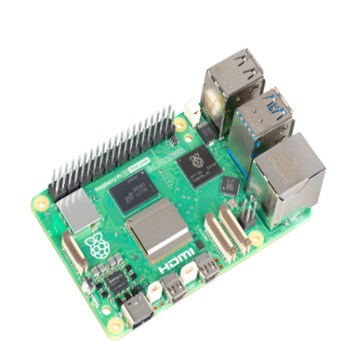

The Raspberry Pi 5 functions as the primary embedded controller of the system. Although the CNN model is processed on a separate computer or server, the Raspberry Pi is responsible for capturing real-time images, managing device operations, transmitting frames, and displaying monitoring results. The 16GB RAM variant provides smoother performance for handling live video streams and interfacing with multiple peripherals. (Estimated Cost: ₱12,000.00)
Table 12
Raspberry Pi 5 Datasheet
Parameter | Specification
Processor | Broadcom BCM2712, Quad-core ARM Cortex-A76 @ 2.4GHz
GPU | VideoCore VII, supporting OpenGL ES 3.1 & Vulkan 1.2
RAM | 16GB LPDDR4X-4267
Storage | microSD card slot (SDR104 high-speed mode)
Wireless | Dual-band Wi-Fi 802.11ac, Bluetooth 5.0/BLE
Ethernet | Gigabit Ethernet
USB Ports | 2× USB 3.0, 2× USB 2.0
Camera/Display I/O | Dual 4-lane MIPI transceivers
Video Output | 2× micro-HDMI supporting dual 4K60 output
Power Input | USB-C, 5V 5A recommended
Operating Temp. | 0°C to 50°C
Dimensions | 85 mm × 56 mm

Figure 33
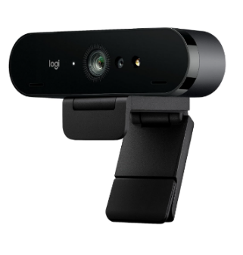
Logitech BRIO 4K Webcam

The Logitech BRIO 4K Webcam serves as the vision sensor of the system, capturing high-resolution facial images necessary for analyzing sleep deprivation indicators such as eye redness, drooping eyelids, and facial fatigue. Its clarity and autofocus capabilities ensure sharp frames, which are crucial for effective facial recognition and feature extraction. (Estimated Cost: ₱7,800.00)
Table 13
Logitech BRIO Datasheet
Parameter | Specification
Sensor | 13 MP CMOS
Resolution | 4K @ 30fps, 1080p @ 60fps, 720p @ 90fps
Field of View | 65° / 78° / 90° adjustable
Video Enhancements | HDR, RightLight™ 3, autofocus
Microphones | Dual omni-directional mics
Connectivity | USB 3.0 Type-A (USB-C compatible)
Power | USB-powered (5V)
Focus Type | Autofocus
Compatibility | Windows, macOS, Linux

Figure 34
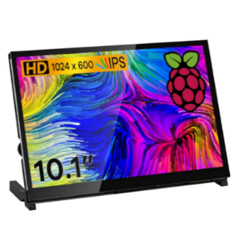
10.1-inch IPS LCD

The 10.1-inch IPS LCD acts as the primary display output for the Raspberry Pi. It allows users to view system notifications, camera previews, and status updates during real-time monitoring. Its wide viewing angle and high-contrast display make it suitable for continuous observation in laboratory and classroom environments. (Estimated Cost: ₱5,945.00)
Table 14
IPS LCD Datasheet

Parameter | Specification
Panel Type | IPS LCD
Size | 10.1 inches
Resolution | 1280 × 800 or 1920 × 1200 (common)
Brightness | 300–400 cd/m²
Viewing Angle | 178° H / 178° V
Contrast Ratio | 800:1 to 1000:1
Input Interface | HDMI video input
Touch Support | Optional (capacitive variants)
Power Input | 5V via micro-USB, 1–1.5A
Refresh Rate | 60 Hz

Figure 35

64GB microSD Card

A 64GB microSD card is used as the main storage for the Raspberry Pi OS, system libraries, and local cache of image logs. It ensures adequate storage space for software dependencies, temporary files, and offline functionality. (Estimated Cost: ₱400.00)

Figure 36
Raspberry Pi 5 Power Supply
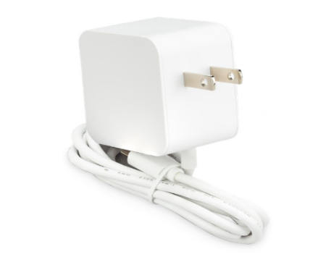

The official Raspberry Pi 5 power supply provides the stable electrical input required to maintain optimal device performance. Since the Raspberry Pi will run continuously during testing and operation, a reliable power source prevents sudden shutdowns and processing disruptions. (Estimated Cost: ₱950.00)
Table 15
Raspberry Pi Power Supply Datasheet
Parameter | Specification
Input Voltage | 100–240V AC, 50/60 Hz
Output Voltage | 5V DC
Output Current | 5A
Connector | USB Type-C
Efficiency Rating | DOE Level VI
Safety | Overvoltage, overcurrent, and  short-circuit protection

Figure 37
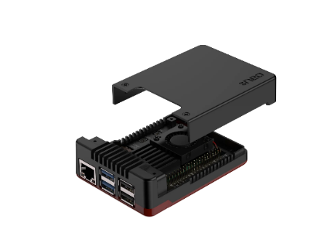
Raspberry Pi 5 Case

A protective Raspberry Pi case was included to secure the board during operation, prevent physical damage, and improve airflow. Enclosing the board also minimizes accidental disconnections and protects the circuitry in laboratory or classroom environments. (Estimated Cost: ₱650.00)
Figure 38
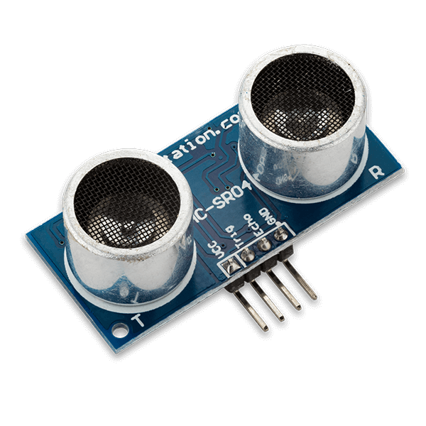
Ultrasonic Sensor (HC-SRO4)

The ultrasonic sensor (HC-SR04) will be used to determine the distance between the student and the camera prior to image capture. This ensures that the learner is within the appropriate range of 0.5 to 1.0 meters before the system begins face capturing. (Estimated Cost: ₱100.00)
Table 16
Ultrasonic Sensor Datasheet
Parameter | Specification
Operating Voltage | 5 V DC (some clones support 3.3–5 V)
Operating Current | ~15 mA typical
Working Frequency | 40 kHz ultrasonic burst
Measuring Range | 2 cm (min) – 400 cm (max) non-contact measurement
Resolution / Accuracy | ~ 3 mm (0.3 cm) under ideal conditions
Beam / Measuring Angle | < 15° cone
Trigger Input | 10 µs TTL pulse on “Trig” pin
Output | Pulse on “Echo” pin; pulse width proportional to distance
Dimensions | ~ 45 mm × 20 mm × 15 mm
Typical Applications | Distance measurement / object detection, obstacle avoidance

Figure 39
Temperature Sensor (Adafruit AMG8833)
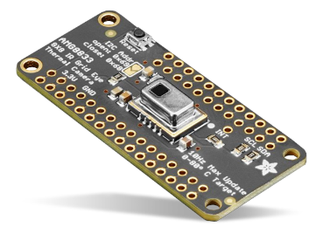

The Adafruit AMG8833 will be used to monitor the student’s facial and ambient temperature. This allows the system to detect the presence of the user, ensuring that there is a live user and to proceed to facial capture (Estimated Cost: ₱1900.00)
Table 17
Temperature Sensor Datasheet
Parameter | Specification
Sensor Type | 8×8 IR thermal sensor array (64 thermopile pixels)
Temperature Measurement Range | ~ 0 °C to 80 °C (32 °F to 176 °F)
Temperature Accuracy | ± 2.5 °C (± 4.5 °F) under typical conditions
Detection Distance | Detects human-sized heat sources up to ~ 7 meters (when properly calibrated)
Sampling Rate / Frame Rate | Up to 10 Hz (frames per second)
Interface | I²C communication interface (SDA, SCL), optional interrupt pin (INT)
Power Supply | 3.3 V (via onboard regulator; board accepts 3–5 V)
Dimensions (Breakout Board) | ~ 50 mm × 23 mm × 6.1 mm (approximate, depends on board version)
Typical Applications | Thermal imaging, human presence detection, basic temperature mapping

Figure 40
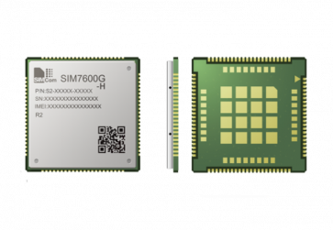
GSM Module (SIM7600G-H)

The GSM Module will be used to automatically send SMS notifications to the parent if the system detects signs of sleep deprivation in a student, ensuring timely communication of the student’s health status (Estimated Cost: ₱3000.00)

Figure 41
3D Printed Enclosure
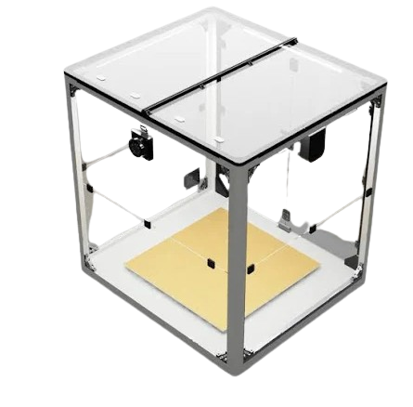

The customized 3D-printed enclosure houses the Raspberry Pi, webcam, and LCD in a unified modular unit. It enhances system portability, provides cable management, and gives the prototype a professional appearance suitable for deployment and demonstration. (Estimated Cost: ₱2,000.00)

APPENDIX B
Software Requirements

Software Requirements
Python Programming Language. Python is a powerful, high-level programming language, utilized for artificial intelligence and machine learning applications. It has a straightforward and clear syntax, making it suitable for both beginners and professionals. Python supports several programming paradigms, including object-oriented, procedural, and functional programming. In this study, Python serves as the programming language for developing and training the CNN.
Flask Framework. Flask is a Python web framework that is lightweight and adaptable and is used to create online apps and APIs. Because it adheres to the Model–View–Controller (MVC) architecture, developers may design interactive, scalable, and modular applications. The web-based interface in this study that links the CNN model and the Firebase database will utilize the framework.
TensorFlow Library. TensorFlow is an open-source platform and software system of deep learning built by Google, and is used to create and train neural networks effectively. The adoption of Keras into TensorFlow helps to simplify the process of model creation, training, and deployment. TensorFlow will be used in the current research to perform the training of MobileNetV3 to identify facial cues of sleep deprivation among students.
OpenCV Library. OpenCV (Open-Source Computer Vision Library) is a machine learning software library which offers image and video processing tools. It can support real time face detection, feature extraction and image manipulation, applicable in facial recognition applications. This paper will apply OpenCV to get facial images with the camera and send it to the CNN model to follow the analysis and detect sleep deprivation.
Firebase Database. Firebase is a database service created and managed by Google based on a cloud platform. Firebase will be used in this paper as the primary student data storage system, student data detection system, and system-logs storage system enabling easy retrieval of information for students.
Raspberry Pi OS. Also known as Raspbian OS, an operating system that is optimized based on Raspberry Pi hardware. It offers a lightweight and stable environment to run Python programs, device drivers, as well as peripheral interfaces needed by the project.

